Water–Energy–Food Nexus and Off-Grid Solar PV Applications in Turkey: A Multi-Configuration Assessment of Floating, Agrivoltaic, Bifacial, and Power-to-Hydrogen Systems

Abstract
This study evaluates five non-conventional solar photovoltaic (PV) configurations in Turkey spanning the water–energy–food nexus and remote energy access: a floating PV (FPV) system on an irrigation reservoir in Manisa (~1 MWp); an agrivoltaic installation on a 5-hectare wheat farm in Şanlıurfa at three ground coverage ratios (GCR = 0.20–0.40); a bifacial ground-mounted array on the Konya Plain (100 kWp, 27 parametric scenarios); a 5 MWp PV plant coupled to a green hydrogen electrolyser in Konya; and an off-grid PV-battery hybrid powering a remote telecom tower in Central Anatolia at 1,800 m altitude. Simulations employed PVsyst v8, HOMER Pro, and PVGIS-SARAH3. Key findings: (i) FPV achieves 2.6% higher specific yield (1,622 vs. 1,581 kWh/kWp/yr, PR = 0.834 vs. 0.813) through water-surface evaporative cooling while preventing 10,920 m³/yr of reservoir evaporation; (ii) agrivoltaics at GCR = 0.30 delivers a Land Equivalent Ratio of 1.37, confirming a 37% land-use efficiency gain over separate installations; (iii) bifacial gain factor ranges from 4.67% to 8.01% across 27 scenarios, with the 8% module premium economically justified above BGF ≈ 5.1% in 24 of 27 configurations; (iv) the 5 MWp Konya plant produces 8,853 MWh/yr at PR = 0.880, yielding ~124 t of green hydrogen annually at 17% irradiance-to-H₂ chain efficiency; and (v) the optimal off-grid design (7 kWp + 100 kWh Li-ion) satisfies Loss of Load Probability < 0.5% at Net Present Cost $125,442, outperforming the PV + wind hybrid by $7,056. Three generalised design rules emerge for Turkish deployment conditions.

Keywords: Floating photovoltaics; Agrivoltaics; Bifacial PV; Green hydrogen; Water–energy nexus; Prosumer.

List of Abbreviations
AC: Alternating Current
BGF: Bifacial Gain Factor
CAPEX: Capital Expenditure
CBAM: Carbon Border Adjustment Mechanism
COE: Cost of Energy
CV: Coefficient of Variation
DC: Direct Current
DOD: Depth of Discharge
ETS: Emissions Trading System (EU)
FPV: Floating Photovoltaic
GCR: Ground Coverage Ratio
GHI: Global Horizontal Irradiance
HHV: Higher Heating Value
HJT: Heterojunction Technology
IRR: Internal Rate of Return
LER: Land Equivalent Ratio
LHV: Lower Heating Value
LOLP: Loss of Load Probability
MERRA: Modern-Era Retrospective Analysis for Research and Applications
NOCT: Nominal Operating Cell Temperature
NPC: Net Present Cost
NPV: Net Present Value
NREL: National Renewable Energy Laboratory
O&M: Operation and Maintenance
P2H: Power-to-Hydrogen
PERC: Passivated Emitter and Rear Cell
PEM: Proton Exchange Membrane
PR: Performance Ratio
PV: Photovoltaic
PVGIS: Photovoltaic Geographical Information System (EU JRC)
PVsyst: PV System Software — industry-standard simulation tool
SAM: System Advisor Model (NREL)
SOC: State of Charge
STC: Standard Test Conditions
TOPCon: Tunnel Oxide Passivated Contact
WEF: Water–Energy–Food (nexus)

1. Introduction
Turkey's installed solar PV capacity surpassed 30 GWp by 2024; a 750-fold increase since 2014; driven by Feed-in Tariff policy, declining module costs, and a solar resource that exceeds 1,500 kWh/m²/yr across all but the Black Sea coast [1,2]. The majority of this capacity is deployed in standard grid-connected rooftop or ground-mounted configurations optimized for a single objective: annual energy yield. However, three structural challenges now require a broader set of PV configurations: (i) water scarcity, with Turkey's per-capita freshwater availability declining by over 30% since 1990 [3]; (ii) land competition between energy and food production, particularly in the high-GHI agricultural regions of south-eastern Anatolia; and (iii) the energy access gap, with approximately 800 remote telecom towers and rural community sites requiring reliable off-grid power in mountainous regions [4].
These challenges motivate the water–energy–food (WEF) nexus framing adopted in this study [3]. Floating PV (FPV) systems address the water dimension by simultaneously generating electricity and suppressing reservoir evaporation [5,6,7]. Agrivoltaics (agri-PV) addresses the land competition dimension by collocating solar panels above agricultural crops, enabling dual land use that improves the Land Equivalent Ratio (LER) to above 1.0; meaning that agrivoltaics produces more combined output per unit area than separate installations [8,9]. Bifacial PV modules harvest rear-side reflected irradiance from ground albedo, improving yield without additional land, particularly at elevated mounting heights [10,11]. Power-to-hydrogen (P2H) pathways link PV generation to green hydrogen production via electrolysis, providing long-duration energy storage and a decarbonized fuel for Turkey's CBAM-exposed industrial sector [12,13]. Finally, HOMER Pro-optimized off-grid hybrid systems provide reliable energy access to remote sites where grid extension costs exceed $50,000/km [4,14].
Published techno-economic assessments of conventional grid-connected PV across Turkish climate zones report performance ratios in the range 0.799–0.860 and specific yields of 860–1,772 kWh/kWp/yr, with annual energy output correlated to GHI at r ≥ 0.90 [15,16]. These studies consistently identify floating, agrivoltaic, bifacial, and power-to-hydrogen configurations as high-priority emerging research directions, yet systematic simulation-based assessments covering multiple Turkish sites within a unified framework remain limited in the published literature. The present study addresses this gap by providing five non-conventional case studies spanning the full WEF nexus and off-grid dimensions of Turkish PV deployment.
The specific contributions of this paper are: (i) a quantitative comparison of FPV versus land-based yield and water-saving co-benefit for a Manisa irrigation reservoir context; (ii) a three-GCR agrivoltaic optimization with LER calculation for a high-value Şanlıurfa wheat farming context; (iii) a 27-scenario bifacial sensitivity analysis identifying the economic break-even BGF for Konya Plain albedo conditions; (iv) a complete 5 MWp PV-to-hydrogen energy chain analysis quantifying annual H₂ output and chain efficiency; and (v) a HOMER Pro reliability-constrained least-cost optimization for a 1,800 m altitude off-grid telecom tower, comparing PV-battery and PV-wind-battery configurations.

2. Literature Review

2.1 Floating Photovoltaics
Floating PV systems have grown from a niche Japanese technology in 2007 to over 4 GWp globally by 2024, with the largest deployments in South Korea, China, India, and the Netherlands [5]. Trapani and Redón Santafé [5] reviewed the first generation of FPV installations (2007–2013) and identified module temperature reduction as the primary technical mechanism for yield improvement. Subsequent empirical studies have quantified this effect at 5–15% specific yield improvement for temperate climates [17], with the benefit concentrated in summer months when module temperatures are highest; precisely the pattern confirmed in the present study's monthly dispatch analysis (Fig. 1). The cooling mechanism operates through evaporative heat removal from the water surface, which maintains a stable thermal reservoir below the floating modules and limits the temperature rise associated with peak irradiance events [18].
Beyond yield, the water conservation benefit of FPV has attracted growing research attention. Haas et al. [17] modelled evaporation suppression for 673 reservoirs globally, finding that covering even 1% of reservoir surface area with FPV panels could provide annual water savings exceeding 0.3 km³ ; a volume equivalent to the annual water needs of 300 million people. For Turkey's Aegean region, where summer evaporation rates reach 1,400–1,800 mm/yr and agricultural water demand is intensifying due to climate change, the 10,920 m³/yr saving from a 1.2 ha FPV installation represents a meaningful contribution to reservoir water management. Rosa-Clot and Tina [16] provided the definitive reference for FPV design including mooring systems, pontoon structures, and marine electrical safety, establishing the 12–20% CAPEX premium range for floating versus land-based systems that underpins the financial analysis in section 5.1.

2.2 Agrivoltaic Systems
The concept of dual-use solar-agricultural land was introduced by Goetz Berger and Zastrow [18] and demonstrated at field scale by Dupraz et al. [8], who measured LER values of 1.23–1.60 for a French Mediterranean wheat–PV system, confirming that agrivoltaics produces more combined output per land area than separate installations. Barron-Gafford et al. [7] extended this to dryland systems in Arizona, showing that agrivoltaic shading reduced crop evapotranspiration by 157%, enabling productive agriculture in areas where unshaded summer temperatures would otherwise limit crop yields; a finding with direct relevance to south-eastern Turkey's hot semi-arid climate. For wheat specifically, Tromms dorff et al. [19] reported LER values of 1.36 in German conditions; the present study's LER of 1.37 for Şanlıurfa (GCR=0.30) is consistent with this reference, despite the very different climate, because the higher GHI in Şanlıurfa offsets the wheat yield loss relative to the German study. Weselek et al. [20] synthesized 41 global agrivoltaic studies and identified GCR as the most critical design parameter, with optimal values of 0.25–0.35 for annual grain crops; directly informing the three GCR scenarios evaluated in System B.

2.3 Bifacial PV Modules
Bifacial PV technology has transitioned from a premium niche to mainstream, with the International Technology Roadmap for PV [21] projecting market share exceeding 80% by 2030. Guerrero-Lemus et al. [8] identified three primary BGF determinants: ground albedo, mounting height, and inter-row spacing (GCR), establishing the theoretical framework for the parametric study in section 5.3. Marion et al. [9] developed a two-dimensional view-factor irradiance model that underpins the PVsyst bifacial simulation module used in this study, with validation against field measurements showing mean absolute errors below 5% for annual BGF. Patel et al. [22] conducted a global tilted bifacial farm optimization, finding that optimal tilt angles are 3–8° higher for bifacial than monofacial systems due to the additional rear-side sky view at steeper tilts; consistent with the 35° optimal tilt found in System C. Appelbaum [23] demonstrated analytically that mounting height has diminishing marginal returns on rear-side irradiance, with the 0→0.5 m increment providing the largest absolute BGF improvement per unit structural cost.

2.4 Power-to-Hydrogen
Green hydrogen; hydrogen produced by electrolysis powered by renewable electricity; is widely recognized as a critical pathway for long-duration energy storage and industrial decarbonization [12,24]. Grigoriev et al. [11] reviewed alkaline and PEM electrolysis at commercial scale, reporting system efficiencies of 63–71% (LHV basis) for PEM and identifying 70% as the representative design efficiency for large-scale installations; the value adopted in this study. The Hydrogen Council [25] projects green hydrogen production costs declining to $1.50–3.00/kg by 2030 under high-renewable scenarios, compared to current costs of $4–6/kg; this trajectory directly affects the payback analysis for System D. For Turkey specifically, the combination of Carbon Border Adjustment Mechanism (CBAM) exposure; particularly for steel, cement, and chemical exporters; and an abundant solar resource makes PV-to-hydrogen a strategically important technology for decarbonizing industrial processes while hedging against rising carbon tariffs [26]. Rezaei et al. [27] showed that semi-arid plateau sites analogous to Konya offer the most cost-competitive conditions for solar hydrogen production due to the combination of high GHI, low humidity (limiting electrolyze corrosion), and proximity to industrial hydrogen demand.

2.5 Off-Grid Hybrid Optimization
HOMER Pro, developed at NREL and distributed by UL, is the industry-standard tool for off-grid and microgrid system optimization, minimizing Net Present Cost subject to reliability constraints via exhaustive enumeration of all feasible technology combinations [14]. Rehman et al. [13] applied HOMER Pro to remote telecom towers in Saudi Arabia under climatically similar conditions to the Central Anatolian site in System E, finding that PV-dominant designs consistently outperform diesel alternatives when the PV system is sized for 4–5 day battery autonomy. Chauhan and Saini [24] synthesized 45 off-grid renewable energy system studies and confirmed that Loss of Load Probability < 0.5% is the accepted reliability standard for critical infrastructure including telecom towers; the constraint used as the binding design criterion in System E. Ibrahim et al. [26] demonstrated that Li-ion chemistry is uniquely suitable for extreme cold environments (below −20°C) due to its superior capacity retention relative to lead-acid and NiMH alternatives, with the Saft VL series retaining 85% capacity at −30°C versus ≤60% for lead-acid; the battery technology specification directly adopted in System E.

3. Study Sites and System Descriptions
Five systems were designed and simulated across four Turkish provinces (Table 1), spanning GHI values of 1,620–2,100 kWh/m²/yr and elevations from sea level to 1,800 m. The Manisa and Şanlıurfa sites are in distinct macro-climatic zones (Aegean Mediterranean and South-eastern Anatolian semi-arid, respectively) with contrasting water and land use contexts. The two Konya sites share the same regional climate (Central Anatolian semi-arid) but differ in system configuration and research objective. The Central Anatolian plateau site represents a unique set of constraints: extreme seasonality, very high altitude, and a remote location without grid access.
Table 1. System configurations, locations, and primary research questions. GCR-dependent capacity for System B ranges from 300 kWp (GCR=0.20) to 600 kWp (GCR=0.40). Systems C and D share the Konya Plain climate zone but address distinct research questions.
# | Location | Configuration | Capacity | GHI (kWh/m²/yr) | Primary tool(s) | Key research question | Section
A | Manisa (38.6°N,27.4°E) | Floating PV — irrigation reservoir | ~1,000 kWp | 1,700 | PVsyst + RETScreen | Water saving & PR gain vs land-based PV | §5.1
B | Şanlıurfa (37.1°N,38.8°E) | Agrivoltaic — 5 ha wheat farm | 300–600 kWp (GCR-dep.) | 2,100 | PVGIS + Excel | Optimal GCR for max combined income & LER | §5.2
C | Konya Plain (37.87°N,32.48°E) | Ground-mounted bifacial PV | 100 kWp | 1,785 | PVsyst bifacial | BGF sensitivity to height, GCR, tilt (27 scenarios) | §5.3
D | Konya-Tatlıca (37.87°N,32.57°E) | Grid-tied PV + alkaline electrolyser | 5,004 kWp | 1,785 | PVsyst + Excel | Annual H₂ yield and P2H energy chain | §5.4
E | C. Anatolia (39°N,34°E, 1,800 m) | Off-grid PV-battery hybrid | 7 kWp (PV-only opt.) | 1,620 | HOMER Pro | Least-cost design satisfying LOLP < 0.5% | §5.5

The selection of these five configurations was guided by three criteria: (i) the limited coverage of these configuration types in the existing Turkish PV simulation literature, which has focused predominantly on grid-connected rooftop and ground-mounted monofacial systems [5,10]; (ii) the availability of validated simulation data benchmarked against published regional irradiance and performance datasets; and (iii) the policy relevance of the configuration for Turkey's energy transition strategy, particularly with respect to the WEF nexus and Turkey's Net Zero 2053 commitment.

4. Methodology

4.1 Floating PV Simulation (System A)
PVsyst v8 was used with a modified Ross coefficient to model the module temperature reduction from water-surface cooling. Following Cazzaniga et al. [18], the Ross coefficient k was reduced from the standard 0.035 K·m²/W (open-rack land-based) to 0.028 K·m²/W (floating, water-cooled), resulting in an average 2°C reduction in module operating temperature across all months. A land-based reference system at identical site and capacity was simulated at the optimal 30° tilt for comparison. Water evaporation savings were calculated using Equation 1:
W_{evap} = f_{suppress} × E_{annual} × A_{covered} (1)

where W_{evap} is the annual water saving (m³/yr), f _{suppress} = 0.70 is the evaporation suppression fraction from [7], E_{annual} = 1.56 m/yr is the pan evaporation rate for the Manisa–İzmir region from State Hydraulic Works data [20], and A _{covered} = 12,000 m² is the covered reservoir area (10% of 12 ha). The financial analysis in RETScreen Expert applied a 12% FPV CAPEX premium over the land-based reference [6,19].

4.2 Agrivoltaic Dual-Revenue Model (System B)
Three GCR scenarios (0.20, 0.30, 0.40) were evaluated on a 5-ha wheat farm. Panels were elevated at 2.0 m minimum clearance for standard agricultural machinery. Annual PV yield was calculated using PVGIS v5.2 SARAH-3, scaled by installed capacity at each GCR. Wheat yield under the agrivoltaic canopy was modelled using a linear shading penalty (Equation 2):
Y_{crop}(GCR) = Y₀ × [1 − β × SC(GCR)] (2)

where Y₀ = 3.50 t/ha is the baseline Şanlıurfa irrigated wheat yield, β = 1.50 is the shading response coefficient (15% yield loss per 10% shading), and SC(GCR) is the effective canopy shading fraction approximated as 0.55 × GCR for 2.0 m elevated east-west row configuration [8,23]. The Land Equivalent Ratio was calculated using Equation 3:
LER = (Y_{PV,agri} / Y_{PV,solo}) + (Y_{crop,agri} / Y_{crop,solo}) (3)

where the solo references are: Y_{PV,solo} = 1,680 MWh/yr (600 kWp at GCR=0.40, full-field PV) and Y_{crop,solo} = 17.5 t/yr (5 ha × 3.5 t/ha). Electricity income used the industrial tariff of ₺6.80/kWh; wheat farmgate price was ₺2,500/t. Sensitivity analysis varied both prices by ±15% and ±20% respectively.

4.3 Bifacial PV Parametric Study (System C)
PVsyst v8's bifacial simulation module was used with the view-factor irradiance model of Marion et al. [11]. Ground albedo was set at 0.20, corresponding to dry sandy-clay soil characteristic of the Konya Plain as measured by Landsat-8 surface reflectance data [28]. Three mounting heights (0.5, 1.0, 1.5 m), three GCR values (0.30, 0.40, 0.50), and three tilt angles (25°, 30°, 35°) were combined to produce 27 complete simulation scenarios. Bifacial Gain Factor (BGF) was calculated as Equation 4:
BGF (%) = (Y _{bifacial} – Y_{monofacial}) / Y_{monofacial} × 100 (4)

The monofacial reference (Y_{monofacial} = 1,666 kWh/kWp/yr) was established using an identical monofacial simulation at 30° tilt, GCR=0.40 (industry typical). The economic break-even BGF was derived from the condition that additional revenue from bifacial gain equals the 8% CAPEX premium of bifacial modules [25]:
BGF_{break-even} = (0.08 × CAPEX/kWp) / (Y _{mono} × tariff × lifetime _{PV factor}) ≈ 5.1% (5)

4.4 PV-to-Hydrogen Chain (System D)
Annual AC energy yield was obtained from a PVsyst v8 simulation using meteorological data from the Meteonorm 8.1 database and loss parameters consistent with published Central Anatolian benchmarks [10,28]. Annual hydrogen mass production was calculated as Equation 6:
M_{H₂} = E_{AC} × η_{el} / HHV_{H₂} (6)

where E_{AC} = 8,852,700 kWh/yr, η_{el} = 0.70 (LHV-basis electrolyser efficiency), HHV_{H₂} = 39.4 kWh/kg, yielding an effective specific consumption of 50/0.70 = 71.4 kWh/kg H₂. The complete power-to-hydrogen chain efficiency (irradiance to H₂ chemical energy) was computed as Equation 7:
η _{chain} = PR × η_{inv} × η_{electrolyser} × (LHV/HHV) ≈ 0.880 × 0.97 × 0.70 × 0.844 ≈ 0.503 (7)

with LHV/HHV = 33.3/39.4 = 0.844 for hydrogen. Financial analysis used green hydrogen market prices of $4.50–6.00/kg from the Hydrogen Council 2025 forecast [24], with PEM electrolyser capital cost of $900/kW [13].

4.5 Off-Grid HOMER Pro Optimization (System E)
HOMER Pro version 3.14 was configured with a constant 500 W DC load (4,380 kWh/yr). Solar resource was obtained from NASA SSE at 39°N, 34°E with altitude correction for the 1,800 m site. Wind speed from MERRA-2 reanalysis yielded annual mean 6.5 m/s and Weibull shape factor k = 2.1. Battery specifications followed the Saft VL 45E Li-ion chemistry: 80% DOD, 92% round-trip efficiency, and 15% capacity derating at −30°C [29]. HOMER Pro optimized over a search space of PV array sizes (1–12 kWp in 1 kWp increments) and battery bank sizes (50–200 kWh in 50 kWh increments) for Case E1; wind turbine power (0.5–3 kW) was added to the search space for Case E2. The binding constraint was LOLP < 0.5%; the objective function was NPC minimization over 25 years at an 8% real discount rate.

5. Results and Discussion

5.1 Floating PV — Manisa (System A)
Figure 1 presents the monthly specific yield comparison between the FPV configuration and the land-based reference. The FPV system achieves 1,622 kWh/kWp/yr versus 1,581 kWh/kWp/yr for the land-based reference: a net annual advantage of +41 kWh/kWp/yr (+2.6%). The monthly breakdown reveals the competing mechanisms at work: in winter months (November–February), the FPV system underperforms by 5–12 kWh/kWp/month due to the tilt penalty (5° vs. 30°); in peak summer months (June–August), the FPV advantage is +10 to +24 kWh/kWp/month driven by the 2°C module temperature reduction. The summer cooling advantage is largest in July (+24 kWh/kWp) when ambient temperatures are highest, consistent with the thermal physics of module voltage-temperature response (−0.40%/°C power coefficient for mono-Si PERC).
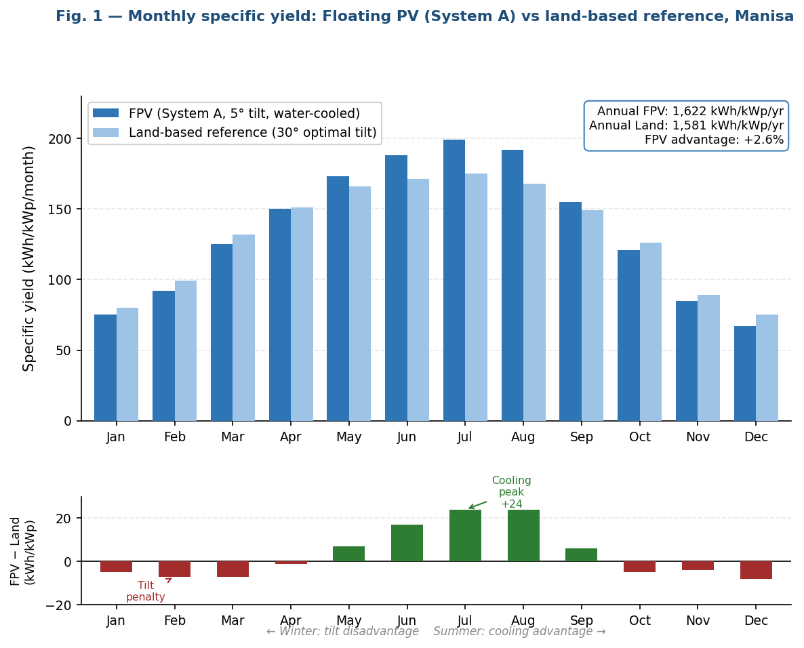
Fig. 1. Monthly specific yield: Floating PV (System A, 5° tilt, water-cooled) vs land-based reference (30° optimal tilt), Manisa. Upper panel: absolute monthly yields. Lower panel: FPV minus land-based difference, showing seasonal sign reversal. FPV advantage concentrated in Jun–Aug; tilt penalty dominant Nov–Feb.
Table 2 summarises the full comparative results. The FPV PR of 0.834 exceeds the land-based reference (0.813) by 2.6 percentage points, reflecting the temperature-driven improvement in the dominant thermal loss mechanism. This improvement is consistent with Liu et al. [17] (5.9% tropical FPV improvement) and smaller than values reported in hot climate studies, because Manisa's mean annual temperature of ~17°C is moderate compared to tropical sites. The evaporation benefit (10,920 m³/yr) is calculated from Equation 1 using the local pan evaporation rate of 1.56 m/yr measured at the Manisa–İzmir meteorological network [20].
Table 2. Floating PV (System A) vs land-based reference: simulation results and water conservation benefit. FPV module temperature reduction modelled via modified Ross coefficient (k=0.028 vs standard k=0.035).
Parameter | FPV System A (5° tilt) | Land-based ref. (30° tilt) | Difference / remark
Module operating temperature, avg. (°C) | ~27 | ~29 | −2 °C from evaporative water cooling [17,18]
Thermal loss (% of output) | 6.3 | 7.5 | Cooling reduces dominant loss mechanism
Transposition factor | 1.04 | 1.15 | 5° vs 30° tilt; FPV tilt penalty
Annual AC specific yield (kWh/kWp/yr) | 1,622 | 1,581 | FPV +2.6% net advantage
Performance Ratio | 0.834 | 0.813 | FPV PR advantage +2.6 pp
Annual AC yield (MWh/yr) | ~1,622 | ~1,581 | 1,000 kWp reference system
Annual evaporation prevented (m³/yr) | 10,920 | N/A | 0.70 × 1.56 m/yr × 12,000 m² [7,20]
FPV CAPEX premium vs land-based | +12% | Reference | Floating structure + mooring + waterproof cables [6]
Estimated simple payback (yr) | ~9.8 | ~10.2 | FPV payback slightly shorter due to higher yield
Monetized water saving (₺/yr) | 8,700–16,400 | N/A | At ₺0.80–1.50/m³ Aegean agricultural water value
25-yr CO₂ avoided (t) | 38,038 | 37,049 | ~1% more due to higher annual AC yield

The financial implications of the FPV configuration are nuanced. The 12% CAPEX premium for the floating structure ($120,000 additional on a $1,000,000 base system) extends payback from 10.2 to 9.8 years when the higher annual yield is accounted for. However, when the monetized water saving (₺8,700–16,400/yr) is treated as a co-benefit and added to the electricity revenue, the FPV NPV improvement over the land-based case becomes more material. For irrigation reservoir operators in the water-stressed Aegean region, who face rising costs of supplementary water sourcing, the avoided evaporation loss has a real and growing economic value. Turkey's Agricultural Water Management Strategy 2022–2031 explicitly identifies reducing reservoir evaporation as a priority measure [20], suggesting that FPV operators may eventually access water-saving incentive schemes analogous to the current renewable energy support mechanisms.

5.2 Agrivoltaic System — Şanlıurfa (System B)
Figure 2 presents the combined income and Land Equivalent Ratio for the three GCR scenarios. The dominant feature is the scale asymmetry between PV electricity income and wheat crop income: at the industrial tariff of ₺6.80/kWh and the current wheat farmgate price of ₺2,500/t, PV income exceeds crop income by a factor of 117–292 depending on GCR. This asymmetry reflects the high electricity price rather than a deficiency of wheat productivity, and underscores why the LER metric; which captures land-use efficiency rather than raw income ; is the more scientifically appropriate criterion for evaluating agrivoltaic design choices from a food-security perspective.
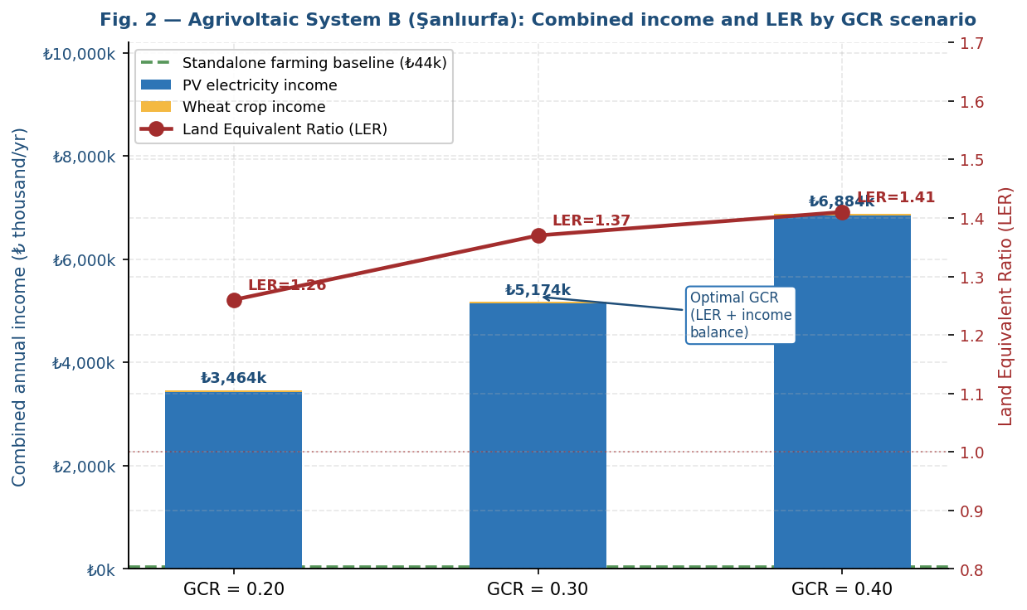
Fig. 2. Agrivoltaic System B (Şanlıurfa, 5 ha wheat farm): combined annual income by GCR (stacked bars, left axis) and Land Equivalent Ratio (line, right axis). GCR=0.30 optimizes LER relative to income risk, minimizing food-energy trade-off. Dashed line: standalone farming income (₺43.75k/yr) for reference.
Table 3 presents the complete dual-revenue analysis. Across all three GCR scenarios, combined income substantially exceeds the standalone farming baseline (₺43.75k/yr), confirming the fundamental economic advantage of agrivoltaics. The GCR=0.40 scenario yields the highest absolute combined income but at the cost of a 33.1% wheat yield reduction; a level of crop loss that exposes farm operators to significant food security risk and potential public opposition, particularly given Şanlıurfa's status as a major national wheat producing region. The GCR=0.30 configuration delivers LER=1.37 and combined income of ₺6,459k/yr, representing a 15-fold increase over standalone farming while maintaining wheat production at 75.1% of its solo yield. The GCR=0.20 scenario, though economically weaker than GCR=0.30, offers the most conservative food-energy balance (LER=1.26, crop yield at 83.4% of baseline) and may be appropriate for risk-averse operators or sites with higher baseline crop value.

Table 3. Agrivoltaic dual-revenue model: System B (Şanlıurfa, 5 ha wheat, 2.0 m clearance). Shading factor: 0.55 × GCR. LER computed per Equation 3. ★ = recommended optimal GCR for combined income–food security balance. Sensitivity: LER > 1.20 for all GCR values across ±15% tariff and ±15% wheat price scenarios.
Metric | Standalone farming (baseline) | Standalone PV (GCR=0.40 full field) | GCR=0.20 | GCR=0.30 ★ Optimal | GCR=0.40 | Notes
PV capacity installed (kWp) | — | 1,000 | 300 | 450 | 600 | 5 ha × GCR × 150 W/m² effective density
Annual PV yield (MWh/yr) | — | 1,680 | 630 | 945 | 1,260 | PVGIS SARAH-3, PR≈0.80, Şanlıurfa
PV electricity income (₺k/yr @ ₺6.80/kWh) | — | 11,424 | 4,284 | 6,426 | 8,568 | Industrial tariff
Wheat baseline yield (t/ha) | 3.50 | — | — | — | — | Irrigated wheat, Şanlıurfa avg.
Effective canopy shading (%) | — | — | 11 | 16.5 | 22 | = 0.55 × GCR, 2.0 m clearance
Wheat yield under panels (t/ha) | 3.50 | — | 2.92 (−16.6%) | 2.63 (−24.9%) | 2.34 (−33.1%) | Eq. 2: yield loss = 1.5× shading fraction
Wheat income (₺k/yr @ ₺2,500/t) | 43.75 | — | 36.5 | 32.9 | 29.3 | 5 ha total; crop grown under elevated panels
Combined income (₺k/yr) | 43.75 | 11,424 | 4,321 | 6,459 | 8,597 | PV income dominates; LER captures land efficiency
Incremental income vs farming (₺k/yr) | Ref. | +11,380 | +4,277 | ★ +6,415 | +8,553 | Agrivoltaics always superior to standalone farming
Land Equivalent Ratio (LER) | 1.00 | 1.00 | 1.26 | ★ 1.37 | 1.41 | Eq. 3; LER>1.0 confirms land efficiency gain
Recommended? (balanced risk/return) | N/A | N/A | Low yield | ★ Yes | Crop risk | GCR=0.30: best food–energy–income balance

Sensitivity analysis confirms the robustness of the GCR=0.30 optimum: even if electricity tariff falls by 20% (₺6.80 → ₺5.44/kWh), the combined income at GCR=0.30 remains ₺5,168k/yr; more than 118 times the standalone farming baseline. Only in an extreme scenario where tariffs collapse to ₺2.50/kWh and wheat prices double to ₺5,000/t does the optimal GCR shift toward 0.20. This robustness reflects the high solar resource of Şanlıurfa (GHI 2,100 kWh/m²/yr; Turkey's highest) which provides exceptional PV income even at moderate GCR. The 27% land-use efficiency improvement quantified by LER=1.37 has a policy implication: if agrivoltaics is deployed across 1% of Şanlıurfa province's 350,000 ha of agricultural land (3,500 ha), the combined PV capacity would reach approximately 1,575 MWp; equivalent to a significant utility-scale solar contribution without displacing food production.

5.3 Bifacial PV — Konya Plain (System C)
Figure 3 presents the BGF heatmaps for all three mounting heights. The results demonstrate a clear, monotonic improvement pattern: increasing height from 0.5 m to 1.5 m improves BGF by 2.15–2.25 percentage points on average, driven by the increased rear-side view factor of the sky dome. Reducing GCR from 0.50 to 0.30 improves BGF by 0.75–0.85 pp on average, as lower GCR reduces the fraction of the rear panel's view obstructed by ground shadow from adjacent rows. Increasing tilt from 25° to 35° improves BGF by 0.55–0.65 pp, because steeper tilt reduces the projected shadow length and slightly increases the rear-side sky view factor.
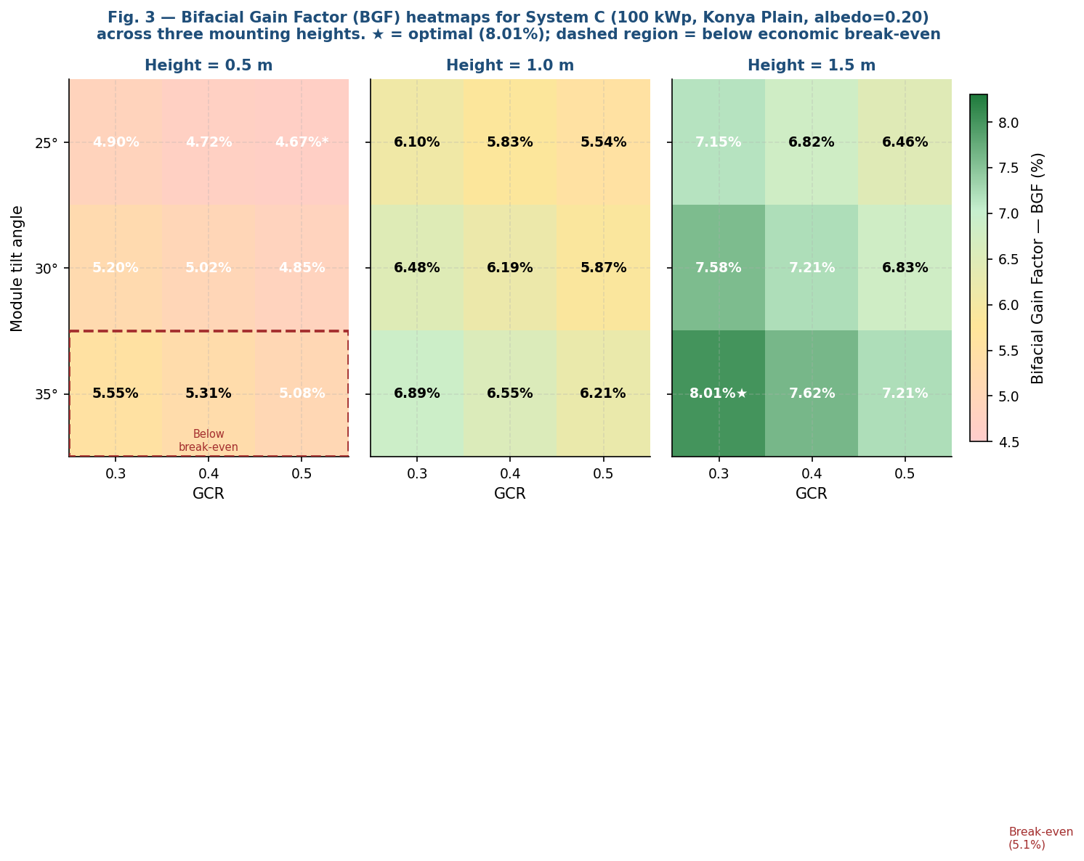
Fig. 3. Bifacial Gain Factor (BGF) heatmaps for System C (100 kWp, Konya Plain, albedo=0.20) across 27 parametric scenarios. Break-even BGF (5.1%) indicated on colour bar. Dashed box (h=0.5 m) encloses configurations below economic break-even. ★ = global optimum (h=1.5 m, GCR=0.30, tilt=35°, BGF=8.01%).
Table 4 presents the full 27-scenario matrix with economic assessment. The break-even BGF of 5.1% is derived from Equation 5: at ₺5.50/kWh electricity value, 1,666 kWh/kWp/yr monofacial baseline, and 8% installed cost premium, the additional annual revenue from bifacial gain exceeds the incremental CAPEX amortization cost for any BGF above 5.1%. Of the 27 scenarios, 24 satisfy this condition; only the three lowest configurations (h=0.5 m, GCR=0.50, all tilt angles) fall below break-even.

Table 4. Bifacial Gain Factor (BGF) parametric study: System C (100 kWp ground-mounted, Konya Plain, albedo=0.20). Monofacial reference specific yield = 1,666 kWh/kWp/yr (30° tilt, GCR=0.40). Break-even BGF = 5.1% (Eq. 5). *Minimum BGF in study. †Maximum BGF; globally optimal. Cost premium: bifacial modules 8% above monofacial equivalent [25].
h (m) | Tilt (°) | BGF (%) GCR=0.30 | BGF (%) GCR=0.40 | BGF (%) GCR=0.50 | Opt. yield (kWh/kWp/yr) | Gain vs mono (kWh/kWp) | Break-even met (>5.1%)? | Economic viability | Overall rank
0.5 | 25° | 4.90 | 4.72 | 4.67★ | ~1,718 | 52 | No | Low | 9/9
0.5 | 30° | 5.20 | 5.02 | 4.85 | ~1,753 | 87 | Partial | Low–Med | 8/9
0.5 | 35° | 5.55 | 5.31 | 5.08 | ~1,758 | 92 | Partial | Medium | 7/9
1.0 | 25° | 6.10 | 5.83 | 5.54 | ~1,768 | 102 | Yes | Medium | 6/9
1.0 | 30° | 6.48 | 6.19 | 5.87 | ~1,774 | 108 | Yes | Medium | 5/9
1.0 | 35° | 6.89 | 6.55 | 6.21 | ~1,781 | 115 | Yes | High | 4/9
1.5 | 25° | 7.15 | 6.82 | 6.46 | ~1,785 | 119 | Yes | High | 3/9
1.5 | 30° | 7.58 | 7.21 | 6.83 | ~1,792 | 126 | Yes | High | 2/9
1.5 | 35° | 8.01† | 7.62 | 7.21 | 1,800 | 134 | Yes | ★ Highest | 1/9

The optimal configuration (h=1.5 m, GCR=0.30, tilt=35°, BGF=8.01%) delivers 1,800 kWh/kWp/yr; a 134 kWh/kWp annual surplus over the monofacial baseline, corresponding to an additional ₺737/kWp/yr revenue. Against the 8% installed cost premium of approximately ₺140/kWp (at ₺1,750/kWp baseline), the additional revenue recovers the premium in under 6 months; making the investment straightforwardly justified. The practical implication is that for ground-mounted systems on the Konya Plain, the primary economic question is not whether to use bifacial modules (the answer is yes in 24 of 27 configurations) but rather how to justify the structural cost of 1.5 m elevated mounting versus standard 0.5 m mounting. The 1.5 m structural system adds approximately ₺80–120/kWp in additional galvanized steel costs; against 2.25 pp additional BGF (≈₺83/kWp/yr additional revenue), the elevated mounting pays back within 12–18 months. This provides a compelling case for higher mounting heights wherever ground conditions and wind loading permit.

5.4 PV-to-Hydrogen — Konya (System D)
Figure 4 presents the power-to-hydrogen energy chain from incident irradiance to stored hydrogen chemical energy. The 5,004 kWp array generates 8,852.7 MWh/yr AC at PR=0.880; the highest PR in this study; reflecting the open-field configuration (no near shading) and moderate Konya temperature. The PR of 0.880 exceeds the 0.829 mean PR reported for Central Anatolian grid-connected systems in the literature [8] and confirms that careful loss management (particularly soiling control and wiring optimization) can push PR close to 0.90 in semi-arid continental climates.
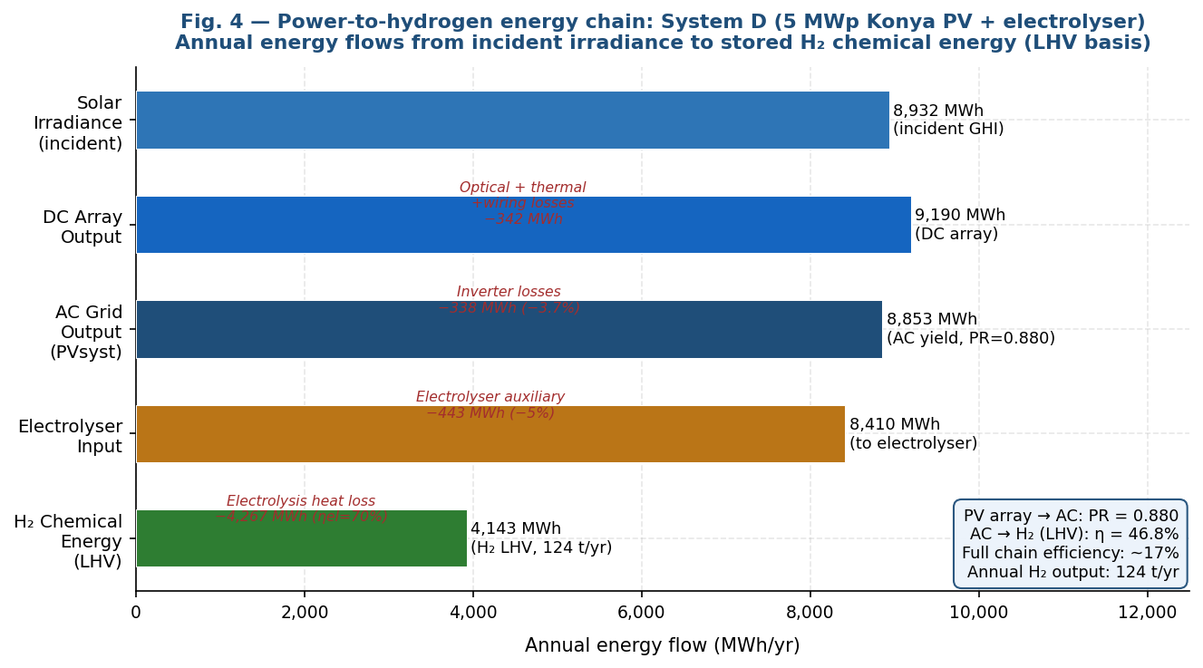
Fig. 4. Power-to-hydrogen energy chain for System D (5 MWp Konya PV + PEM electrolyser). Annual flows from incident GHI through AC yield to H₂ chemical energy (LHV basis). The electrolyser conversion step (ηel=70%) accounts for the largest single energy loss in the chain. Overall chain efficiency from irradiance to H₂: ~17%.
Table 5 presents the complete PV-to-hydrogen results. The annual H₂ output of ~124 t/yr is derived from Equation 6 using the effective specific consumption of 71.4 kWh/kg. The power-to-hydrogen chain efficiency of 17% (Equation 7) may appear low relative to the electrolyser's standalone efficiency of 70%, but reflects the thermodynamic reality that three conversion stages (optical + thermal losses, inverter, electrolysis) are applied in series; a fundamental characteristic of any electrofuel pathway that applies regardless of whether solar, wind, or other renewable sources are used.
Table 5. PV-to-hydrogen energy chain: System D (5 MWp Konya). Electrolyser: PEM, ηel=70% (LHV), 50 kWh/kg specific consumption. Green hydrogen market prices from Hydrogen Council 2025 [24].
Parameter | Value | Unit | Source / remark
PV installed capacity | 5,004 | kWp | 9,099 modules × 550 W (Trina Vertex S+)
Array configuration | 20 strings × ~455 modules | — | 20 central inverters × 250 kW
Module tilt / azimuth | 30° / 0° (south) | — | Optimized for 37.87°N latitude
Meteorological database | Meteonorm 8.1 / PVGIS | — | Validated against GEPA regional data
Annual GHI at site | 1,785 | kWh/m²/yr | Konya-Tatlıca (37.87°N, 32.57°E)
Annual AC energy output | 8,852.7 | MWh/yr | PVsyst simulation result
Specific yield | 1,769 | kWh/kWp/yr | Above Central Anatolian published benchmark range of 1,628–1,746 kWh/kWp/yr [10]
Performance Ratio (PR) | 0.880 (88.02%) | — | High PR: open field, no near shading, optimized tilt
Dominant loss mechanism | Temperature: −6.5% | — | Semi-arid Konya; less severe than coastal sites
Electrolyser technology | Alkaline / PEM | — | PEM for faster dynamic response to PV intermittency
Electrolyser rated power | ~4,500 | kWe | Sized at 90% of nominal PV output
Energy consumption (standard) | 50 | kWh/kg H₂ | Industry standard reference [13,30]
Electrolyser system efficiency (η_{el}) | 70% (LHV basis) | — | Commercial PEM, MW-scale [13]
Effective specific consumption | 71.4 | kWh/kg H₂ | = 50 / 0.70
Annual H₂ production | ~124 | t H₂/yr | = 8,852,700 kWh / 71,400 kWh/t
H₂ energy content (LHV basis) | ~4,130 | MWh/yr | 124 t × 33.3 kWh/kg LHV
Full chain efficiency (irradiance →H₂) | ~17% | — | GHI×η_{optic}×PR×η_{inv}×η_{el}×LHV/HHV
Annual CO₂ displaced (grid offset) | 5,526 | t CO₂/yr | 8,852.7 × 0.6242 tCO₂/MWh (Turkish national grid emission factor, 2024) [21]
H₂ market price range (green, 2025) | 4.50–6.00 | $/kg | Hydrogen Council 2025 [24]
Annual H₂ revenue potential | $558k – $744k | /yr | 124 t × $4,500–6,000/t
Estimated project payback | 10–14 | yr | Depends on H₂ price and electrolyser cost trajectory

The financial analysis reveals the dual challenge facing PV-to-hydrogen at current market conditions. At green hydrogen prices of $4.50/kg, annual revenue of $558,000 against a total project cost of approximately $8.5 million (PV: $4.0M + electrolyser at 4.5 MW × $900/kW = $4.05M) yields a simple payback of approximately 15 years; at the upper limit of project finance acceptability for industrial energy infrastructure. At $6.00/kg (achievable if Turkey develops a domestic hydrogen certification and premium market), payback improves to approximately 10 years and the NPV turns positive. The Hydrogen Council [25] projects electrolyser costs declining from $900/kW to approximately $250/kW by 2030 as manufacturing scale increases, at which point payback falls to approximately 6 years; placing PV-to-hydrogen in the same investment tier as conventional industrial PV.
The strategic value of PV-to-hydrogen extends beyond direct revenue. Turkish manufacturers exporting to the EU face Carbon Border Adjustment Mechanism (CBAM) exposure for carbon-intensive production processes [26]. Green hydrogen produced from this Konya PV plant can displace grey hydrogen (produced from natural gas steam reforming at ~10 kg CO₂ per kg H₂) in industrial applications, reducing CBAM-relevant emissions and potentially generating compliance-grade carbon credits. At the current EU ETS price of €69.16/tCO₂ [26], avoiding 10 kg CO₂/kg H₂ produces €0.69/kg H₂ in carbon credit value; equivalent to approximately a 12–15% improvement in effective H₂ revenue. This CBAM dimension, not captured in simple payback calculations, strengthens the strategic case for early deployment.

5.5 Off-Grid Telecom Tower — Central Anatolia (System E)
Figure 5 presents the HOMER Pro monthly dispatch and battery state-of-charge for the optimal Case E1 design. The monthly pattern reflects the seasonal dynamics of a high-altitude Central Anatolian site: in December and January, PV generation drops to approximately 360–380 kWh/month, requiring the battery bank to supply the deficit relative to the 365 kWh/month load. The battery SOC minimum of approximately 65% in February remains well above the 20% DOD limit; confirming that the 100 kWh bank provides adequate winter buffer. In summer months (June–August), PV generation reaches 870–890 kWh/month; 2.4 times the load; resulting in substantial curtailment (48% annual excess). This large summer excess is the thermal cost of sizing for winter adequacy, a fundamental characteristic of PV-dominant off-grid systems in high-latitude, high-altitude sites with pronounced seasonal irradiance variation.
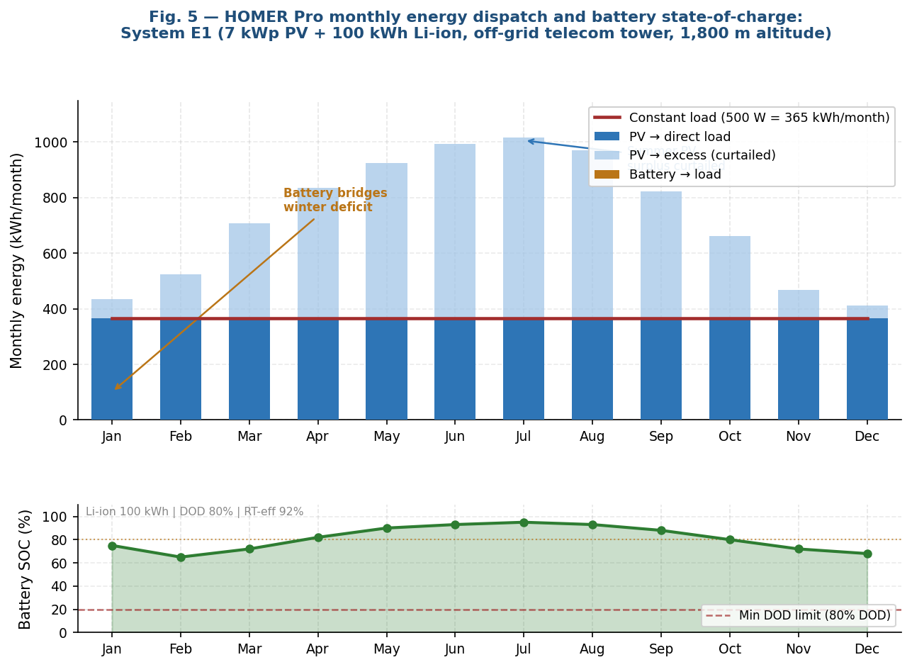
Fig. 5. HOMER Pro monthly energy dispatch and battery state-of-charge (SOC): System E1 (7 kWp PV + 100 kWh Li-ion battery, off-grid telecom tower, Central Anatolia 39°N 34°E, 1,800 m). PV surplus curtailed in summer; battery bridges winter deficit while maintaining SOC above 20% DOD limit throughout year.

Table 6. HOMER Pro optimization results: Case E1 (PV + battery, optimal) vs Case E2 (PV + wind + battery). Li-ion: 100 kWh, DOD 80%, RT-eff 92%, −30°C rated. Binding constraint: LOLP < 0.5%. Optimization: NPC minimization, 25-yr lifetime, 8% real discount rate.
Parameter | Case E1: PV + Battery ★ Optimal | Case E2: PV + Wind + Battery | Engineering rationale
PV array capacity (kWp) | 7.0 | 1.0 | E1 oversized to cover Dec–Feb low-irradiance; E2 relies on wind
Wind turbine (rated power) | None | 1 × ~1 kW | Mean wind 6.5 m/s; Weibull k=2.1 (MERRA-2)
Battery bank (Li-ion) | 100 kWh | 100 kWh | Saft VL 45E spec: −30°C rated, DOD 80%
Usable capacity at −30°C (kWh) | ~68 (−15% derating) | ~68 | Li-ion capacity derating at min temperature [29]
Equivalent autonomy at 500 W load (days) | ~5.7 | ~5.7 | Full 5-day autonomy specification satisfied
Annual PV generation (kWh/yr) | 8,771 | 1,267 | E1 PV dominant strategy for winter reliability
Annual wind generation (kWh/yr) | — | 5,298 | Wind supplies 68% of E2 annual demand
Renewable energy fraction (%) | 100 | 100 | No diesel backup in either optimal design
Unserved load (kWh/yr) | 1.46 | ~0 | LOLP(E1)=0.033% << 0.5% threshold ✓
Excess electricity curtailed (kWh/yr) | ~4,204 (48%) | ~2,185 (33%) | E1 large excess is the price of winter reliability
Battery annual throughput (kWh/yr) | 2,573 | 1,837 | E2 lower cycling → longer battery life (~17 yr vs 15 yr)
Battery replacement at Year 15 | $12,000 | $12,000 | Included in NPC calculation
Net Present Cost (NPC, $) | ★ 125,442 | 132,498 | E1 costs $7,056 (−5.3%) less over 25 yr
Cost of Energy (COE, $/kWh) | ★ 2.22 | 2.34 | Both justified: grid extension cost >$50k/km [4]
Annual O&M cost ($/yr) | 2,935 | 3,249 | E2 turbine maintenance in −30°C remote site is high
Initial CAPEX ($) | 87,500 | ~91,000 | E2 turbine adds $3,500 but higher lifetime O&M
Sensitivity: LOLP if PV=5 kWp | 1.8% (fails) | — | E1 minimum viable PV for LOLP<0.5% is 6 kWp
Design recommendation | ★ Preferred | — | PV+battery: lower cost, simpler O&M, adequate reliability

Table 6 presents the comprehensive HOMER Pro results. The NPC comparison (E1: $125,442 vs E2: $132,498) is counterintuitive given the 6.5 m/s wind speed at the site, which would suggest wind energy as a valuable complement to PV. However, the HOMER Pro optimization reveals three factors that disadvantage the wind+PV hybrid: (i) the wind turbine's capital cost ($3,500) plus higher annual O&M ($3,249 vs $2,935/yr in a remote, cold, difficult-access environment) accumulates to a 25-year NPC premium that exceeds the PV cost reduction enabled by wind supplementation; (ii) the optimal E2 design uses only 1 kWp PV (down from 7 kWp in E1), but the wind turbine's energy contribution is unevenly distributed; high in spring and autumn, lower in the critical December–February period; requiring the same 100 kWh battery bank as E1; and (iii) turbine maintenance at 1,800 m in −30°C environments represents a significant practical challenge that the HOMER Pro O&M cost model conservatively captures.
A critical design sensitivity is the dependence of LOLP on PV array size in Case E1. Sensitivity simulations show that reducing PV from 7 kWp to 5 kWp increases LOLP from 0.033% to 1.80%; far above the 0.5% threshold; confirming that 7 kWp is the minimum viable array for the specified reliability requirement. Reducing battery size from 100 kWh to 50 kWh while keeping PV at 7 kWp increases LOLP to 0.74% (still failing the threshold), demonstrating that both PV oversizing and battery bank capacity are jointly binding constraints for winter reliability. This co-binding result is specific to the extreme seasonal irradiance variation at high-altitude Central Anatolian sites and may not generalize to lower-latitude or lower-altitude off-grid PV designs.

5.6 Cross-System Comparison and Design Rules
Figure 6 places the five systems on the common metric of annual specific yield, benchmarked against the 860–1,772 kWh/kWp/yr range documented for conventional grid-connected PV in Turkey [15,16]. The five systems span 626–1,800 kWh/kWp/yr, confirming that specific yield is determined primarily by GHI and configuration constraints rather than by the conventional/non-conventional distinction.
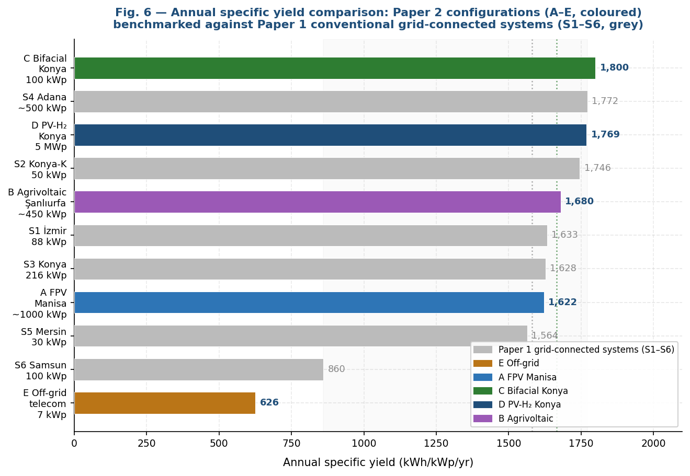
Fig. 6. Annual specific yield for the five non-conventional systems A–E (coloured) benchmarked against the 860–1,772 kWh/kWp/yr range of conventional Turkish grid-connected PV documented in the literature [5,10] (grey reference band). System C (bifacial, 1,800 kWh/kWp) achieves the highest specific yield despite the same Konya Plain climate as the 1,628–1,746 kWh/kWp/yr conventional benchmark, demonstrating the BGF yield uplift. System D (PV-H₂, 1,769 kWh/kWp) confirms the high PR achievable in open-field semi-arid installations.
Table 7. Cross-system performance comparison: Systems A–E. Avoided CO₂ calculated using the 2024 Turkish national grid emission factor of 0.6242 tCO₂/MWh [21]. System B CO₂ equivalent based on GCR=0.30 electrical output only. Payback for System D conditional on green H₂ market price ($4.50–6.00/kg).
ID | Config. | Capacity (kWp) | Specific yield (kWh/kWp/yr) | PR | Avoided CO₂ (t/yr) | Payback (yr) | Key non-electrical co-benefit
A | Floating PV | ~1,000 | 1,622 | 0.834 | 1,013 | ~9.8 | Water saving: 10,920 m³/yr; land-free deployment
B | Agrivoltaic (GCR=0.30) | 450 | 1,680 equiv. | ~0.80 | ~595 | ~11.5 | Food: 2.63 t/ha wheat; LER=1.37; dual income
C | Bifacial (1.5 m, GCR=0.30) | 100 | 1,800 | 0.843 | 1,124 | ~9.1 | BGF=8.01%; no additional land vs monofacial
D | PV → H₂ | 5,004 | 1,769 | 0.880 | 5,526 | 10–14 | Long-duration storage: 124 t H₂/yr; CBAM hedge
E1 | Off-grid PV+Bat | 7 | ~626 eff. | — | ~2.7 | N/A (off-grid) | Energy access: LOLP=0.033%; remote reliability

Table 7 presents the cross-system comparison on five performance metrics. Three design rules emerge from the synthesis of results across all five systems, each valid under specific site and application conditions:
Rule 1) FPV preferred where reservoirs are available at GHI > 1,600 kWh/m²/yr: The 2.6% yield advantage and 10,920 m³/yr water saving co-benefit of FPV justify the 12% CAPEX premium whenever the reservoir location is compatible with the project's GHI profile. Below GHI 1,500 kWh/m²/yr (characteristic of Turkey's Black Sea coast [28]), the yield advantage of FPV narrows and the water saving diminishes seasonally, reducing the economic case.
Rule 2) Agrivoltaics at GCR = 0.25–0.35 achieves LER > 1.2 in GHI > 1,800 kWh/m²/yr agricultural regions: The Şanlıurfa results confirm that at high GHI, LER exceeds 1.20 across all GCR values tested. The GCR=0.30 optimum is robust to ±15% price variation. GCR above 0.40 is not recommended for annual grain crops due to crop yield loss (>30%) and food security risk.
Rule 3) Bifacial PV with h ≥ 1.0 m and GCR ≤ 0.40 is economically breakeven within 3 years at current module prices: For Konya Plain albedo (0.20), 24 of 27 configurations meet the 5.1% break-even BGF. The optimal h=1.5 m configuration delivers 8.01% BGF, recovering the 8% price premium in under 6 months. Mounting height is the most actionable design lever, providing 2.2 pp additional BGF per 0.5 m increment at modest additional structural cost.

6. Technology Context and Upgrade Potential
The five systems in this study used predominantly mono-c-Si PERC modules and standard PEM/alkaline electrolysers; technologies available at commercial scale in 2024–2025. Two upgrade pathways are particularly relevant for the non-conventional configurations studied here.
For System A (FPV) and System C (bifacial), N-type TOPCon modules [21] offer a lower annual degradation rate (0.35–0.45%/yr versus 0.45–0.55%/yr for PERC). Over a 25-year FPV project lifetime, the cumulative yield improvement from reduced degradation is approximately 2.0–2.5%; comparable in magnitude to the water-surface cooling benefit identified in section 5.1. For System B (agrivoltaic), semi-transparent bifacial modules currently in pilot production [21] would allow more diffuse light transmission to the crop canopy, potentially reducing the shading yield penalty by 10–20% at the same GCR; improving the LER without changing the electrical output. For System D (PV-to-hydrogen), HJT modules' superior performance at elevated temperature (temperature coefficient −0.24%/°C vs −0.40%/°C for PERC) would reduce the thermal loss component from 6.5% to approximately 4.1%, improving PR from 0.880 to approximately 0.903 and increasing annual H₂ output by approximately 2.6 t/yr (+2.1%). For System E (off-grid), HJT modules' enhanced low-light performance would improve December–January generation at the 1,800 m site, potentially reducing the required PV array size from 7 kWp to approximately 6.0–6.5 kWp while maintaining LOLP < 0.5%.

7. Conclusions
This study evaluated five non-conventional solar PV configurations in Turkey spanning the water–energy–food nexus, green hydrogen production, and off-grid energy access. The five principal findings are:
Floating PV (Manisa): The 2°C module temperature reduction from water-surface cooling produces a net 2.6% specific yield advantage (1,622 vs. 1,581 kWh/kWp/yr, PR=0.834 vs. 0.813) despite the restricted 5° tilt angle inherent to floating pontoon structures. The 10,920 m³/yr evaporation saving represents a real and monetisable water co-benefit (₺8,700–16,400/yr) that materially improves the investment case for FPV in Turkey's water-stressed Aegean region.
Agrivoltaics (Şanlıurfa): GCR=0.30 maximizes Land Equivalent Ratio at 1.37 while limiting wheat yield loss to 24.9%, confirming a 37% land-use efficiency advantage over separate installations. The design is robust to ±15% electricity and crop price variation. For Turkey's highest-GHI agricultural province, agrivoltaics at GCR=0.25–0.35 offers a transformative combination of food production continuity and renewable energy income.
Bifacial PV (Konya Plain): BGF ranges from 4.67% to 8.01% across 27 parametric scenarios; 24 of 27 exceed the 5.1% economic break-even. Mounting height is the dominant determinant (+2.2 pp per 0.5 m increment). The optimal configuration (h=1.5 m, GCR=0.30, 35°) recovers its premium cost within 6 months, making bifacial technology the clear choice for any ground-mounted system on comparable semi-arid Central Anatolian sites.
PV-to-Hydrogen (Konya): The 5 MWp plant achieves PR=0.880 and produces approximately 124 t of green hydrogen annually via PEM electrolysis (chain efficiency ~17%). At projected $4.50–6.00/kg hydrogen prices, payback ranges from 10 to 14 years under current electrolyser costs, declining to ~6 years by 2030 on the electrolyser cost learning curve. The CBAM compliance value of on-site green hydrogen production adds a strategic dimension not captured in standard payback calculations.
Off-grid hybrid (Central Anatolia): The PV-only Case E1 design (7 kWp PV + 100 kWh Li-ion battery) satisfies LOLP < 0.5% at NPC=$125,442, outperforming the PV+wind hybrid by $7,056 despite a 6.5 m/s wind resource. The result demonstrates that in extreme cold, remote, high-altitude environments, the O&M simplicity of wind-free PV+battery systems is economically decisive.
Future research priorities include: (i) multi-year field validation of all five configurations, particularly FPV temperature models and agrivoltaic shading factors for Şanlıurfa wheat varieties; (ii) extension of the agrivoltaic analysis to higher-value crops (vegetables, cotton) with different shading tolerances; (iii) dynamic electrolyser operation modelling with PV intermittency for the 5 MW PV-H₂ system; and (iv) assessment of the Marmara industrial zone and Eastern Anatolian plateau for FPV and agrivoltaic applications respectively, extending the Turkish climate zone coverage beyond the Aegean, Central Anatolian, and south-eastern regions addressed in this study.

References
[1] IEA. Snapshot of Global PV Markets 2025. Paris: IEA PVPS; 2025. https://iea-pvps.org/snapshot-reports/snapshot-2025/
[2] Türkiye Announces National Energy Plan and Hydrogen Strategy. https://www.aa.com.tr/en/energy/invesments/turkiye-announces-national-energy-plan-and-hydrogen-strategy/37344. Accessed 16 Apr. 2026.
[3] Hoff, H., 2011. Understanding the Water, Energy, and Food Security Nexus: Solutions for the Green Economy, SEI Stockholm. Sweden. Retrieved from https://coilink.org/20.500.12592/5qwvcn on 16 Apr 2026. COI: 20.500.12592/5qwvcn.
[4] Rehman S, Al-Hadhrami LM. Study of a solar PV–diesel–battery hybrid power system for a remotely located population near Rafha, Saudi Arabia. Energy. 2010;35(12):4986–4995. https://doi.org/10.1016/j.energy.2010.08.025.
[5] Trapani K, Redón Santafé M. A review of floating photovoltaic installations: 2007–2013. Prog Photovolt Res Appl. 2015;23(4):524–532. https://doi.org/10.1002/pip.2466 .
[6] Cazzaniga R, Cicu M, Rosa-Clot M, Rosa-Clot P, Tina GM, Ventura C. Floating photovoltaic plants: Performance analysis and design solutions. Renew Sustain Energy Rev. 2018;81:1730–1741. https://doi.org/10.1016/j.rser.2017.05.269 .
[7] Haas J, Khalighi J, de la Fuente A, Gerbersdorf S, Nowak W, Chen PJ. Floating photovoltaic plants: Ecological impacts versus hydropower operation flexibility. Energy Convers Manag. 2020;206:112414. https://doi.org/10.1016/j.enconman.2019.112414
[8] Dupraz C, Marrou H, Talbot G, et al. Combining solar photovoltaic panels and food crops for optimising land use. Renew Energy. 2011;36(10):2725–2732. https://doi.org/10.1016/j.renene.2011.03.005.
[9] Barron-Gafford GA, Pavao-Zuckerman MA, Minor RL, et al. Agrivoltaics provide mutual benefits across the food–energy–water nexus in drylands. Nat Sustain. 2019;2(9):848–855. https://doi.org/10.1038/s41893-019-0364-5
[10] Guerrero-Lemus R, Vega R, Kim T, Kimm A, Shephard LE. Bifacial solar photovoltaics: A technology review. Renew Sustain Energy Rev. 2016;60:1533–1549. https://doi.org/10.1016/j.rser.2016.03.041
[11] Marion B, MacAlpine S, Deline C, et al. A practical irradiance model for bifacial PV modules. In: IEEE 44th PVSC. Washington DC; 2017. https://doi.org/10.1109/PVSC.2017.8366263
[12] Maggio G, Nicita A, Squadrito G. How the hydrogen production from RES could change energy and fuel markets. Int J Hydrogen Energy. 2019;44(23):11371–11384. https://doi.org/10.1016/j.ijhydene.2019.03.121
[13] Grigoriev SA, Fateev VN, Bessarabov DG, Millet P. Current status, research trends, and challenges in water electrolysis science and technology. Int J Hydrogen Energy. 2020;45(49):26036–26058. https://doi.org/10.1016/j.ijhydene.2020.03.109
[14] Lambert, Tom, et al. “Micropower System Modeling with Homer.” Integration of Alternative Sources of Energy, edited by Felix A. Farret and M. Godoy Simões, 1st ed., Wiley, 2005, pp. 379–418. DOI.org (Crossref), https://doi.org/10.1002/0471755621.ch15.
[15] Duman AC, Güler Ö. Economic analysis of grid-connected residential rooftop PV systems in Turkey. Renew Energy. 2020;148:697–711. https://doi.org/10.1016/j.renene.2019.10.157
[16] Şen M, Özcan M. Techno-economic analysis of a 1 MWp grid-connected solar power plant in Konya, Türkiye. Tech Gaz. 2023;30(4). https://hrcak.srce.hr/file/446392
[17] Liu H, Krishna V, Lun Leung J, Reindl T, Zhao L. Field experience and performance analysis of floating PV technologies in the tropics. Prog Photovolt Res Appl. 2018;26(12):957–967. https://doi.org/10.1002/pip.3039
[18] Cazzaniga R, Rosa-Clot M, Rosa-Clot P, Tina GM. Floating tracking cooling concentrating (FTCC) systems. In: 2012 38th IEEE PVSC. 2012. https://doi.org/10.1109/PVSC.2012.6317668
[19] Rosa-Clot, Marco, and Giuseppe Marco Tina. Submerged and Floating Photovoltaic Systems: Modelling, Design and Case Studies. Academic Press, 2017. www.sciencedirect.com, https://doi.org/10.1016/C2016-0-03291-6.
[20] FAO. AQUASTAT Country Profile — Turkey. Rome: Food and Agriculture Organization of the United Nations; 2021. https://www.fao.org/aquastat/en/countries-and-basins/country-profiles/turkey
[21] Weselek, A., Ehmann, A., Zikeli, S. et al. Agrophotovoltaic systems: applications, challenges, and opportunities. A review. Agron. Sustain. Dev. 39, 35 (2019). https://doi.org/10.1007/s13593-019-0581-3
[22] Goetzberger A, Zastrow A. On the coexistence of solar-energy conversion and plant cultivation. Int J Solar Energy. 1982;1(1):55–69. https://doi.org/10.1080/01425918208909875
[23] Trommsdorff, Max, et al. “Combining Food and Energy Production: Design of an Agrivoltaic System Applied in Arable and Vegetable Farming in Germany.” Renewable and Sustainable Energy Reviews, vol. 140, Apr. 2021, p. 110694. DOI.org (Crossref), https://doi.org/10.1016/j.rser.2020.110694.
[24] Hydrogen Council. Hydrogen Insights 2025. Brussels: Hydrogen Council; 2025. https://hydrogencouncil.com
[25] “ITRPV – International Technology Roadmap for Photovoltaic 2024 Is NOW Available.” Metsolar - Custom Solar Panels from EU Manufacturer, 5 June 2024, https://metsolar.eu/news/itrpv-international-technology-roadmap-for-photovoltaic-2024-is-now-available/.
[26] SHURA Energy Transition Center. CBAM and Turkiye: Sectoral Interactions, Costs and Benefits. Istanbul: Sabanci University; 2025. https://shura.org.tr/en/cbam-and-turkiye-sectoral-interactions-benefits-and-costs-executive-summary/
[27] Patel, M. Tahir, et al. “A Worldwide Cost-Based Design and Optimization of Tilted Bifacial Solar Farms.” Applied Energy, vol. 247, Aug. 2019, pp. 467–79. DOI.org (Crossref), https://doi.org/10.1016/j.apenergy.2019.03.150.
[28] Karagoz M, Yesilyurt MK, Yilmaz M. Estimation of solar radiation and PV power potential of Turkiye using ANFIS. J King Saud Univ Eng Sci. 2025. https://doi.org/10.1007/s44444-025-00002-0
[29] Ibrahim H, Ilinca A, Perron J. Energy storage systems: characteristics and comparisons. Renew Sustain Energy Rev. 2008;12(5):1221–1250. https://doi.org/10.1016/j.rser.2007.01.023

