

FACULTY OF INFORMATION AND COMMUNICATION TECHNOLOGY

NAMIBIA TEACHERS RECRUITMENT PORTAL

BY
VICTORIA T. MUUHANGA
STUDENT NO: 220018251

NOVEMBER 2025
IN

PARTIAL FULFILLMENT OF REQUIREMENTS FOR DEGREE IN BUSINESS INFORMATION SYSTEMS
SUPERVISOR MR. J. ILONGA

DECLARATION
I Victoria T. Muuhanga, hereby declare that the project work Namibia Recruitment Portal submitted to The International University of Management, is a record of an original work done by me under the guidance of Mr. J. Ilonga, Faculty Member of the International University of Management, and this project work has not performed the basis for the award of any Degree or diploma/ fellowship and similar project if any.
Student’s name Signature Date
Victoria T. Muuhanga v.muuhanga 21/01/2026

Supervisor’s name Signature Date
Mr. J. Ilonga ………………. ……….………

ABSTRACT

The recruitment of teachers in Namibia has historically been plagued by systemic inefficiencies, geographic exclusion, and prohibitive costs for unemployed graduates. This project, titled the Namibia Teachers Recruitment Portal, was initiated to design and develop a centralized digital solution to address the "wageless" crisis facing unemployed educators who spend scarce resources on transport and courier fees for job applications. The researcher found that the current decentralized, manual recruitment process disproportionately excludes candidates from rural and low socio-economic backgrounds due to the high cost of traveling to regional directorates for interviews. Furthermore, the reliance on physical documentation resulted in a high incidence of lost applications and a lack of real-time data on teacher supply and demand. The project concludes that digitizing the recruitment value chain not only democratizes access to employment opportunities for rural graduates but also provides the MoEAC with critical analytics for workforce planning.

ACKNOWLEDGEMENTS
The researcher wishes to express profound gratitude to the Almighty God for the strength, wisdom, and grace granted throughout the duration of this study.
Sincere appreciation is extended to the supervisor, Mr. J. Ilonga, for their invaluable guidance, constructive criticism, and patience during the development of the Namibia Teachers Recruitment Portal. Their mentorship was instrumental in shaping the direction of this research.
The researcher is also indebted to the unemployed teachers and Ministry of Education, Arts and Culture (MoEAC) officials who participated in the data collection process. Their willingness to share their experiences regarding the challenges of recruitment logistics and transport costs provided the empirical foundation for this study.
Finally, heartfelt thanks go to the researcher's family and friends for their unwavering financial support and encouragement during the challenging moments of this academic journey.

Table of Contents

DECLARATION……………………………………………………………………………………..i
ABSTRACT………………………………………………………………………………………….........ii
ACKNOWLEDGEMENTS iii
LIST OF TABLES vi
Table 3.7.2: applications table vi
Table 3.7.1: schools table vi
Table 3.7.3: job vacancies table vi
Table 3.7.4: principals table vi
Table 3.7.5: jobseekers table vi
Table 3.7.6: users table vi
Table 3.7.7: grades table vi
Table 3.7.8: subjects table vi
Table 3.7.9: admins table vi
Table 3.7.10: levels table vi
LIST OF FIGURES vii
CHAPTER 1: INTRODUCTION AND BACKGROUND OF THE STUDY 1
CHAPTER 2: LITERATURE REVIEW 4
CHAPTER 3: SYSTEM ANALYSIS AND DESIGN 8
Table 3.7.1: schools table 23
Table 3.7.2: applications table 23
Table 3.7.3: job vacancies table 24
Table 3.7.4: principals table 24
Table 3.7.5: jobseekers table 25
Table 3.7.6: users table 25
Table 3.7.7: grades table 25
Table 3.7.8: subjects table 25
Table 3.7.9: admins table 26
Table 3.7.10: levels table 26
Backend (Server-Side & Database) 27
Frontend (User Interface / Client-Side) 28
CHAPTER 4: `IMPLEMENTATION 29
4.1 Introduction 29
4.1.1 Database Connection Configuration 29
CHAPTER 5: TESTING 39
CHAPTER 6: CONCLUSION AND FUTURE WORK 43
REFERENCES 45

LIST OF TABLES
Table 3.4.1: Functionality Requirements

Table 3.7.2: applications table

Table 3.7.1: schools table

Table 3.7.3: job vacancies table

Table 3.7.4: principals table

Table 3.7.5: jobseekers table

Table 3.7.6: users table

Table 3.7.7: grades table

Table 3.7.8: subjects table

Table 3.7.9: admins table

Table 3.7.10: levels table

Table 3.8.1. Minimum Hardware requirement

Table 3.8.2. Minimum Software requirement

Table 5.1.1. Unit Testing

Table 5.1.2. Post-test questionnaire

LIST OF FIGURES
Fig. 3.5.1 Use Case Diagram
Fig. 3.5.2 Class Diagram

Fig. 3.5.3 Admin Login

Fig. 3.5.4 System Architecture

Fig. 3.7: Database Design

CHAPTER 1: INTRODUCTION AND BACKGROUND OF THE STUDY

1.1 Introduction
This Study was intended to design and develop a web-based recruitment portal that addresses the logistical and financial barriers facing unemployed teachers in Namibia. The subject area of this study falls within the domain of Information and Communication Technology (ICT) for Development, specifically focusing on e-governance and digital recruitment systems. In the context of Namibia, the recruitment of educators has historically relied on manual, decentralized processes that require candidates to travel long distances to regional directorates. This traditional approach has become increasingly unsustainable due to the rising costs of transport and the high rate of youth unemployment. By transitioning from a physical to a digital recruitment model, this study explores how technology can democratize access to employment opportunities. The project is significant as it proposes a solution that aligns with national goals for digital transformation, aiming to eliminate the "wageless" costs associated with job seeking and ensure that the most qualified candidates can apply for teaching vacancies regardless of their geographic location or socio-economic status.

1.2 Background
The current recruitment procedures within the Ministry of Education, Arts and Culture (MoEAC) often require applicants to submit physical documentation and attend in-person interviews, regardless of their proximity to the venue. Research indicates that “the geographical vastness of Namibia creates a severe financial crisis for rural applicants, who must spend scarce resources on transport fares without guaranteed employment” (Shikalepo, 2019). Furthermore, “the lack of a centralized digital database has led to inefficiencies where applications are frequently lost or delayed, and recruitment data is not utilized for strategic workforce planning” (Somaeb, 2017). The study is necessitated by the urgent need to modernize these obsolete workflows and address the socio-economic exclusion of poor graduates who cannot afford the "cost of compliance" demanded by the current system.

1.3 Problem Statement
Unemployed teachers in Namibia currently face a prohibitive financial burden when seeking employment, characterized by high transport costs and the need to travel long distances to submit applications or attend interviews. “This money to find money cycle excludes candidates from low socio-economic backgrounds, particularly those in rural areas, effectively denying them equal access to job opportunities” (Namupala, 2016). Additionally, the MoEAC suffers from systemic inefficiencies due to manual record-keeping, resulting in lost documents, a lack of transparency in the selection process, and an inability to match teacher qualifications with specific school vacancies in real-time. There is currently no centralized digital platform to bridge the gap between unemployed graduates and school vacancies, leaving the recruitment process fragmented, costly, and inefficient.

1.4 Aims and Objectives
Aim: The primary aim of this project is to develop the "Namibia Teachers Recruitment Portal," a centralized web-based system that automates the application, selection, and interview scheduling processes for teaching vacancies in Namibia.
Specific Objectives:
- To analyze the current manual recruitment workflows and identify key bottlenecks such as transport costs and document loss.
- To design a centralized database architecture that securely stores applicant profiles, qualifications, and vacancy data.
- To develop a user-friendly web interface that allows candidates to apply for jobs and attend initial interviews.
- To implement an automated matching algorithm that ranks candidates based on MoEAC requirements (e.g., subject specialization, experience).

1.5 Research Questions
- How does the current manual recruitment process impact the financial stability of unemployed teachers in Namibia?
- What are the functional requirements for a digital portal that can effectively replace physical application submissions?
- To what extent can a web-based recruitment system reduce the logistical costs associated with job seeking for rural candidates?

1.6 Justification
The significance of this system lies in its potential to foster equity and efficiency within the public service sector. By digitizing the recruitment value chain, the system will benefit unemployed teachers by removing the need for expensive travel, thereby leveling the playing field for candidates from impoverished backgrounds. For the Ministry of Education, the system offers the benefit of administrative efficiency, reducing the workload associated with manual sorting of applications and minimizing the risk of nepotism through transparent, data-driven selection. Furthermore, the system supports the broader national agenda of the Harambee Prosperity Plan by utilizing ICT to improve service delivery and reduce youth unemployment friction.

1.7 Delimitation
The study is strictly delimited to the recruitment process for government schools under the Ministry of Education, Arts and Culture in Namibia. The system will handle functions related to vacancy advertisement, applicant registration, document submission, and interview scheduling. It will not cover payroll management, teacher disciplinary tracking, or private school recruitment processes. The system is designed for use by two primary user groups: unemployed teaching graduates (applicants), school principal (principal) and Ministry Human Resources officers (administrators).

1.8 Chapter Summary
This chapter introduced the study by outlining the critical challenges in the current teacher recruitment landscape in Namibia. It established the background of the problem, highlighting the financial and geographic barriers facing applicants. The problem statement identified the "wageless" crisis and administrative inefficiencies as key issues to be resolved. The objectives and justification set the stage for the development of the Namibia Teachers Recruitment Portal as a necessary technological intervention. The following chapter will review the existing literature and similar systems to establish a theoretical framework for the project

CHAPTER 2: LITERATURE REVIEW

2.1 Introduction
This chapter reviews the existing literature related to teacher recruitment challenges, the adoption of digital recruitment systems in developing countries, and the theoretical frameworks that underpin the acceptance of such technologies. It provides a critical analysis of the "wageless" crisis facing unemployed graduates in Namibia and evaluates similar existing systems to identify gaps that the proposed Namibia Teachers Recruitment Portal aims to fill. The review is structured to first understand the problem domain, then explore the solution domain, and finally ground the study in established Information Systems theories.

2.2 Teacher Recruitment Challenges in Rural Contexts
The recruitment and retention of qualified teachers in rural areas present a complex challenge for educational administrations globally, and particularly in Namibia. Literature indicates that the disparity between urban and rural schools is not merely infrastructural but also deeply rooted in the logistics of the labor market. Shikalepo (2019) argues that “the geographical vastness of Namibia creates a distance penalty for rural schools, making them less accessible to job seekers who reside in urban centers where most universities are located. This distance translates into a significant financial barrier for unemployed graduates.
2.2.1 The Cost of Compliance for Job Seekers
A recurring theme in recent studies is the prohibitive cost associated with the job search process itself. Namupala (2016) characterizes “the plight of unemployed Namibian youth as a cycle where one needs money to find money." Candidates are often required to travel hundreds of kilometers to regional directorates to submit physical applications or attend interviews. This travel incurs costs for transport, accommodation, and subsistence that are often beyond the means of unemployed graduates. Ndiwakalunga (2015) “supports this by noting that traveling from rural to urban areas for appointments is a costly experience that disproportionately affects those from lower socio-economic backgrounds”. This financial burden effectively excludes a significant portion of the qualified workforce from applying for vacancies in remote areas, exacerbating the teacher shortage in those regions.

2.2.2 Administrative Inefficiencies and Systemic Exclusion
Beyond the financial costs to applicants, the manual recruitment system currently employed by the Ministry of Education, Arts and Culture (MoEAC) suffers from severe administrative inefficiencies. (Somaeb, 2017) identifies that “the lack of a centralized digital database leads to a high incidence of lost applications and procedural inconsistencies”. When recruitment is decentralized and paper-based, the paper trail becomes susceptible to human error and potential manipulation, raising concerns about nepotism and unfairness. Furthermore, (Henry, 2020) suggests that “these systemic inefficiencies contribute to a wageless education crisis, where the possession of a qualification does not guarantee entry into the labor market due to friction in the hiring process”. The absence of a real-time data feedback loop between teacher supply (graduates) and demand (school vacancies) prevents the Ministry from conducting effective workforce planning.

2.3 The Shift to E-Recruitment Systems
The transition from traditional to electronic recruitment (e-recruitment) is widely documented as a critical step for modernizing public service delivery. E-recruitment refers to the use of technology and web-based resources to assist in the recruitment process, including attracting, assessing, and selecting personnel.
2.3.1 Benefits of Digital Recruitment
The primary advantage of e-recruitment is the democratization of access to information. By moving job advertisements and applications online, the geographical barrier is effectively removed. Candidates can apply for positions in any region without leaving their homes, significantly reducing the "cost of compliance" discussed earlier. In the context of the Namibian government, research suggests that e-recruitment can enhance transparency and meritocracy. A study on the Namibian public service indicated that automating recruitment could eliminate bureaucratic delays and the misplacement of documents (The Brief, 2025). Additionally, centralized portals allow for the creation of talent databases, enabling Human Resources departments to search for candidates based on specific criteria such as subject specialization or language proficiency, rather than relying solely on active applicants.

2.3.2 Challenges of E-Recruitment Adoption
Despite the clear benefits, the adoption of e-recruitment in developing contexts is not without challenges. The "digital divide" remains a significant concern. Somaeb (2017) warns that recruitment processes relying heavily on internet access may inadvertently discriminate against candidates with low socio-economic status who lack connectivity or digital literacy. However, the increasing penetration of mobile broadband in Namibia offers a mitigation strategy. Mobile-responsive design and low-bandwidth portals can ensure that digital recruitment remains accessible to a broader demographic. Furthermore, the success of such systems depends heavily on trust. Applicants must be confident that the digital system is secure, impartial, and that their data will not be misused.

2.4 Review of Similar Systems
An analysis of existing systems provides a benchmark for the proposed solution. Currently, there is no dedicated, centralized government portal for teacher recruitment in Namibia. However, general job portals and private sector solutions exist.
2.4.1 Nieis (Namibia Integrated Employment Information System)
The Nieis is a general purpose employment database managed by the Ministry of Labour. While it registers job seekers and vacancies, it lacks the specific functionality required for teacher recruitment, such as filtering by subject specialization (e.g., "History Grade 10-12") or managing school-specific interview schedules. It is largely a repository rather than an active recruitment workflow tool.
2.4.2 Private Job Portals (e.g., Namijob, Pin up Jobs) Private portals in Namibia often aggregate vacancies from newspapers. While they provide digital access to advertisements, the application process usually reverts to manual methods (e.g., "email your CV to..." or "deliver to..."). They do not offer an end-to-end solution that includes application tracking, automated shortlisting, or remote interviewing.

2.4.3 Teacher Recruitment Portals in Other Countries
Countries like South Africa have implemented more robust systems (e.g., the Department of Basic Education's e-recruitment). These systems allow for profile creation and vacancy matching. The proposed Namibia Teachers Recruitment Portal seeks to emulate these features but with specific adaptations for the Namibian context, such as integration with low-bandwidth mobile interfaces and specific support for remote video interviewing to address the transport cost crisis.

2.5 Summary
This chapter provided a review of literature highlighting the severe financial and logistical barriers facing unemployed teachers in Namibia. It established that the current manual system is exclusionary and inefficient. The review of e-recruitment concepts confirmed that a digital solution could address these issues by removing geographic barriers and reducing costs. Finally, the analysis of similar systems revealed a gap in the market for a specialized, end-to-end teacher recruitment portal in Namibia. The next chapter will detail the methodology used to analyze and design this system.

CHAPTER 3: SYSTEM ANALYSIS AND DESIGN

3.1 Introduction
This chapter provides a comprehensive account of the systems analysis and design phase undertaken for the Namibia Teachers Recruitment Portal. It details the systematic process of translating the identified problems specifically the prohibitive transport costs and administrative inefficiencies in teacher recruitment into a concrete technical solution. The chapter outlines the methods employed to gather user requirements from unemployed graduates and Ministry officials, justifies the selection of the software development methodology, and presents a detailed specification of system requirements using the FURPS model. Furthermore, it documents the architectural design, database structure, and user interface prototypes that guide the implementation phase. The goal of this chapter is to provide a blueprint for a system that is not only technically robust but also socially responsive to the wage less crisis facing Namibian educators.

3.2 Gathering of Requirements
The gathering of user and system requirements was a critical phase of the systems analysis activity, aimed at ensuring the final product aligns with the actual needs of its end-users. To achieve a holistic understanding of the recruitment landscape, a mixed-method approach for data collection was utilized, involving semi-structured interviews and document analysis.
3.2.1 Interviews Semi-structured interviews served as the primary method for eliciting qualitative requirements. The study targeted two distinct user groups:
- Unemployed Graduates: A sample of 20 unemployed teachers was interviewed to understand their logistical challenges. Key questions focused on the costs incurred during previous job applications, their access to internet devices, and their comfort level with digital interviews.
- Ministry of Education (MoEAC) HR Officials: Interviews were conducted with 5 Human Resources officers to map the current internal workflow of vacancy advertising and candidate shortlisting.

3.2.2 Document Analysis to supplement the interviews, the researcher analyzed existing physical application forms and government circulars regarding recruitment policies (e.g., Public Service Management Circulars). This document searching provided the necessary data fields required for the database design, ensuring that the digital form captures all legally required information such as Citizenship Status and NQA Qualification Level. Formal records of these analyzed documents are listed in the references and influenced the validation rules specified in Section 3.4.

3.3 Development Method
The Agile Software Development Methodology, specifically the Scrum framework, was chosen to accomplish this project. Agile is an iterative approach that emphasizes flexibility, customer collaboration, and the delivery of functional software components in short cycles known as "sprints."
Justification for Choosing Agile
Agile was selected over traditional methods like the Waterfall model for several strategic reasons:
- Adaptability: The requirements for government systems often evolve. Agile allows for changes to be made late in the development process without derailing the entire project.
- User-Centricity: Given the specific socio-economic constraints of the users (e.g., low bandwidth needs), continuous feedback from unemployed teachers was necessary to refine the interface. Agile’s iterative nature allowed for a prototype to be tested and adjusted based on real-world feedback regarding usability on mobile devices.
- Risk Mitigation: By developing critical features first (e.g., the remote interview module), the highest risks were addressed early in the lifecycle.
Advantages of Agile:
- Faster Delivery: Functional modules (like registration) were ready for testing early, providing immediate value.
- Improved Quality: Regular testing during every sprint ensured that bugs were identified and fixed instantly.
- Stakeholder Engagement: Frequent check-ins with the supervisor and potential users ensured the system remained aligned with the project aims.
Disadvantages of Agile:
- Documentation Creep: Agile focuses on working software over documentation, which can sometimes lead to less comprehensive records if not managed carefully.
- Scope Creep: The flexibility can lead to endless feature additions. This was managed by strictly adhering to the must have priorities defined in the requirements specification.

3.4 Requirements Specification
The requirements for the Namibia Teachers Recruitment Portal were categorized into functional and non-functional requirements. To ensure a comprehensive specification, the FURPS+ model (Functionality, Usability, Reliability, Performance, and Supportability) was utilized.
3.4.1 Functionality Requirements
These requirements define the specific behaviors and functions of the system.
Priority | Requirement ID | Description | Category
High | FR-01 | The system shall allow applicants to register and create a profile using their National ID. | Account Management
High | FR-02 | The system shall allow applicants to upload certified copies of qualifications in PDF format (max 2MB). | Data Entry
High | FR-03 | The system shall provide a VoIP interface for conducting real-time video interviews within the browser. | Remote Interview
High | FR-04 | The system shall allow Administrators to post job vacancies with specific filtering criteria (Region, Subject). | Admin
Medium | FR-05 | The system shall automatically calculate a "Match Score" based on applicant qualifications vs. job requirements. | Automation
Low | FR-06 | The system shall send SMS notifications to applicants when an interview is scheduled. | Notification

Table 3.4.1: Functionality Requirements
3.4.2 Non-Functional Requirements
- Usability:
  - The user interface must be responsive, adapting seamlessly to mobile screens (320px width) as 85% of users access the internet via smartphones.
  - The system must support a "Lite Mode" that disables heavy images for users with limited data bundles.
- Reliability:
  - The system must ensure 99.9% availability during peak recruitment periods (typically January and June).
  - Database backups must be automated daily to prevent data loss.
- Performance:
  - The application dashboard must load in under 3 seconds on a 3G network connection to accommodate rural users.
  - The VoIP module must maintain audio clarity even if video quality degrades due to low bandwidth.
- Supportability:
  - The system code must be written in modular PHP (Laravel) to allow for easy updates and maintenance by Ministry IT staff.
  - The system must be compatible with major browsers (Chrome, Firefox, Opera Mini).

3.5 System Design
This section visualizes the interactions and structural design of the system.
3.5.1 Use Case Diagram
The Use Case model below identifies the primary actors and their interactions with the system.
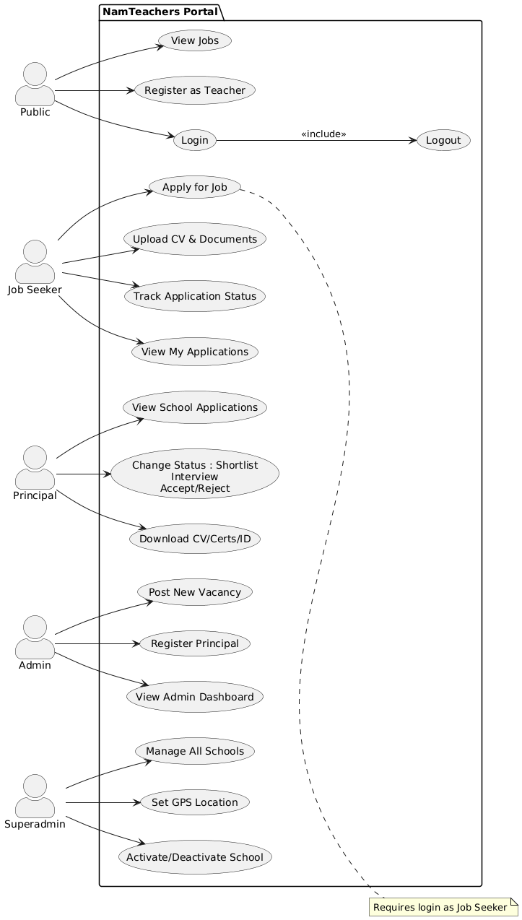
Fig. 3.5.1 Use Case Diagram

3.5.2 Class Diagram

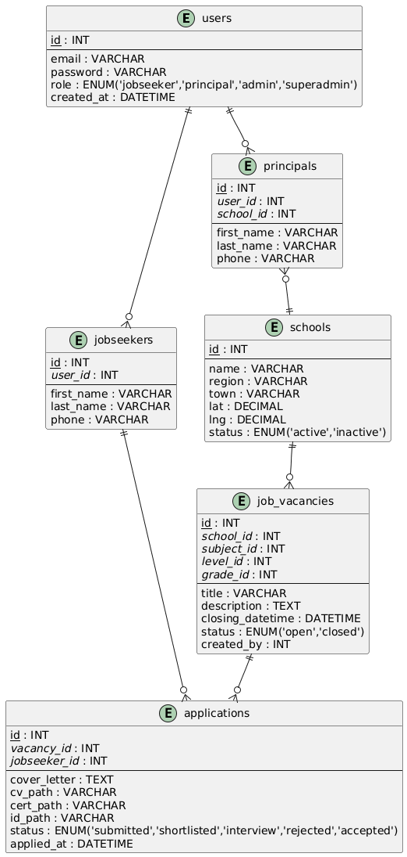

Fig. 3.5.2 Class Diagram

3.5.3 Admin Login
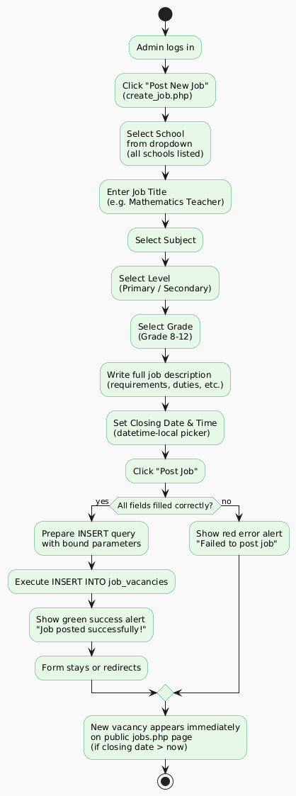

Fig. 3.5.3 Admin Login

3.5.4 System Architecture

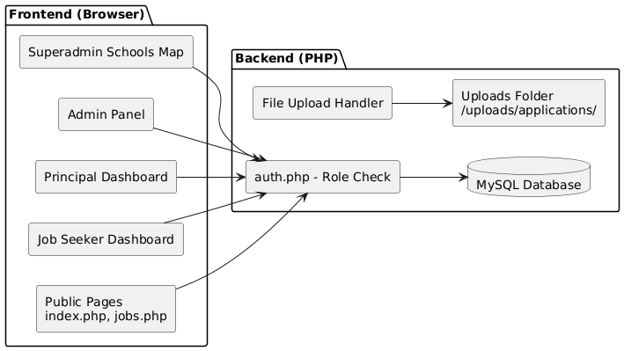

Fig. 3.5.4 System Architecture

3.6 User interface design

This section includes the design of input screens/forms and output screens.


Home page

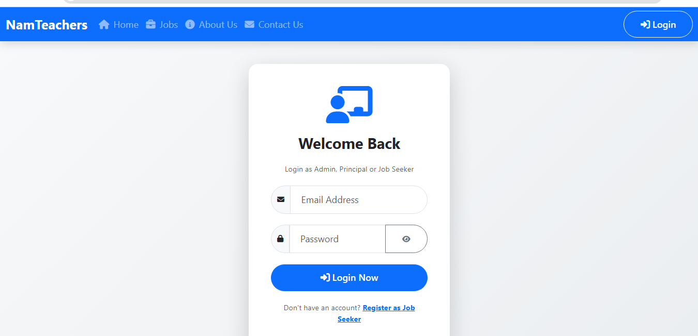
All user login page

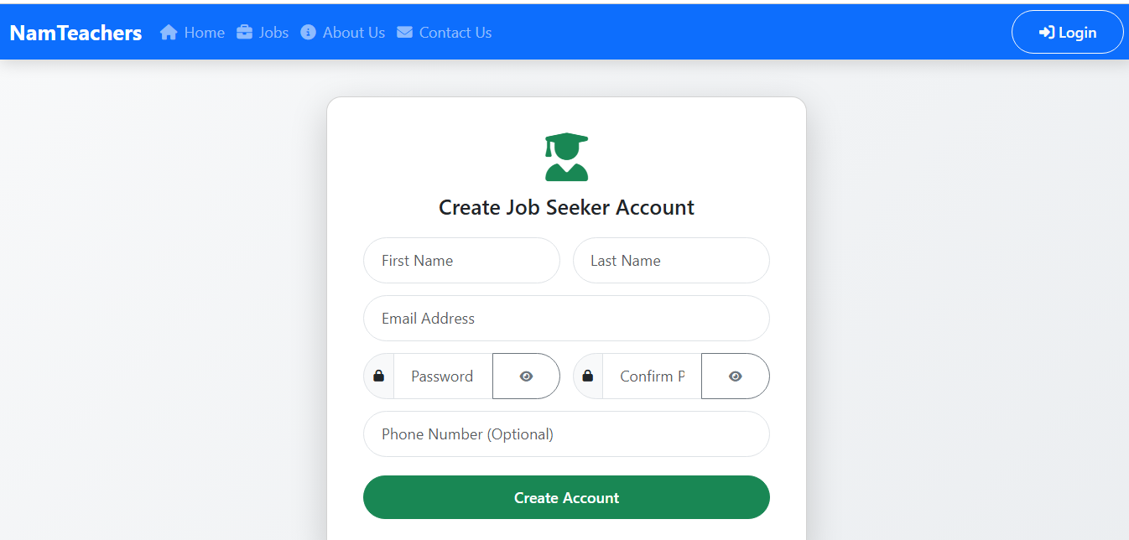
Job seeker/teacher registration page

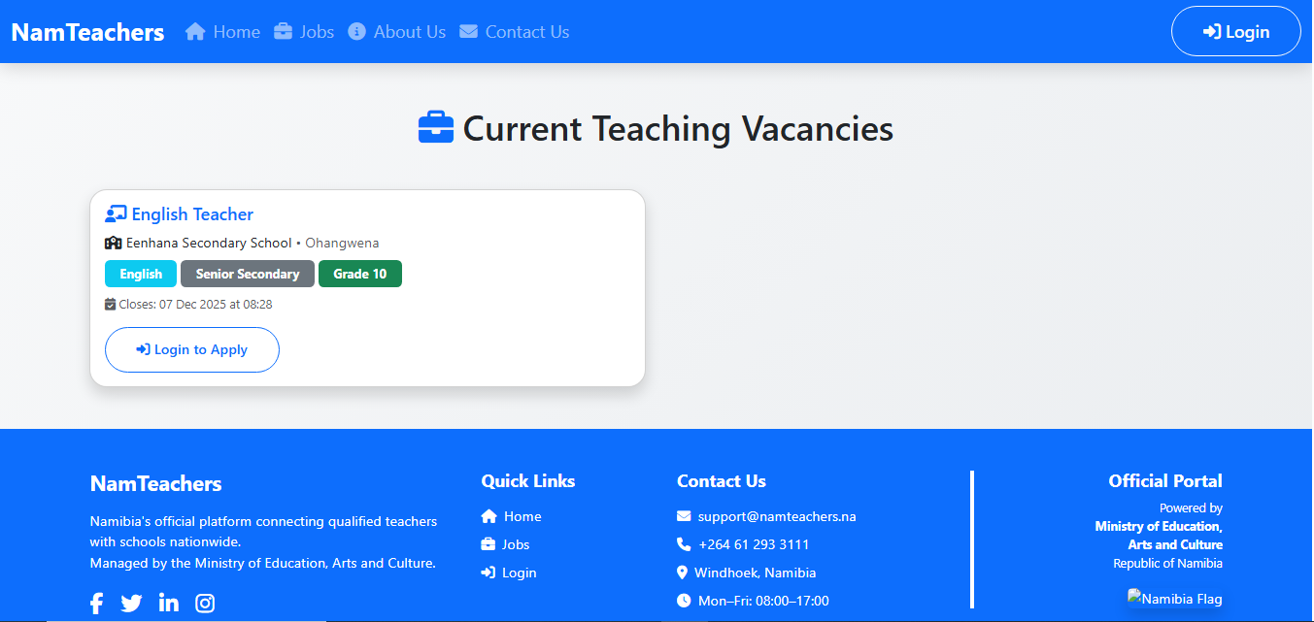
Available teaching vacancies dashboard

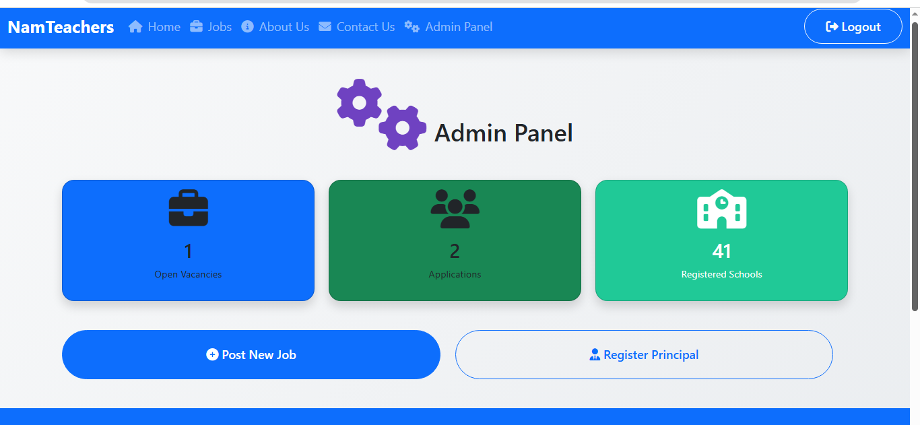
Admin Dashboard

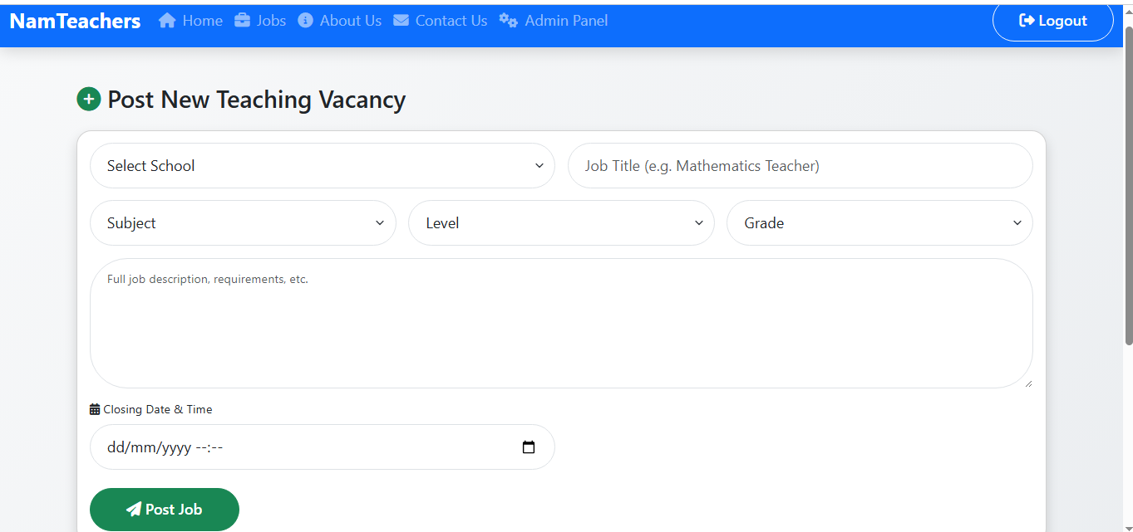
Posting of New Teaching Vacancy form

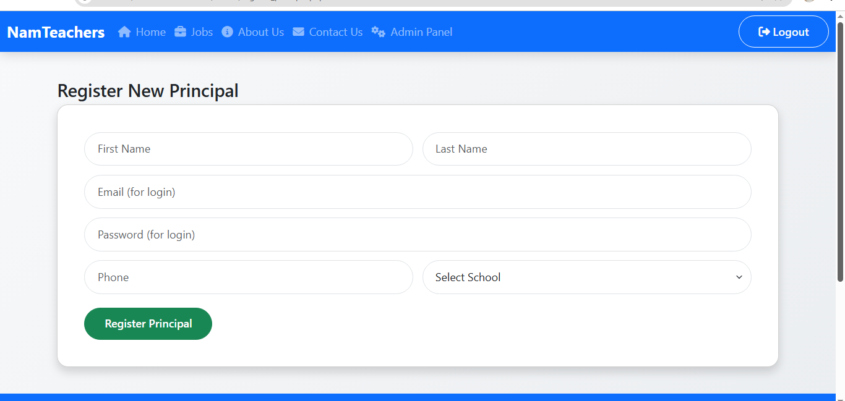
Principal registration form

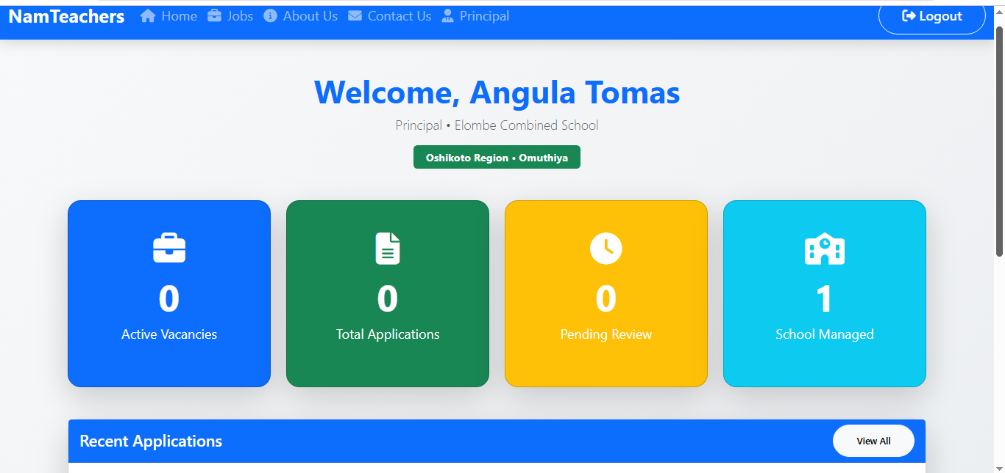
Principal Dashboard

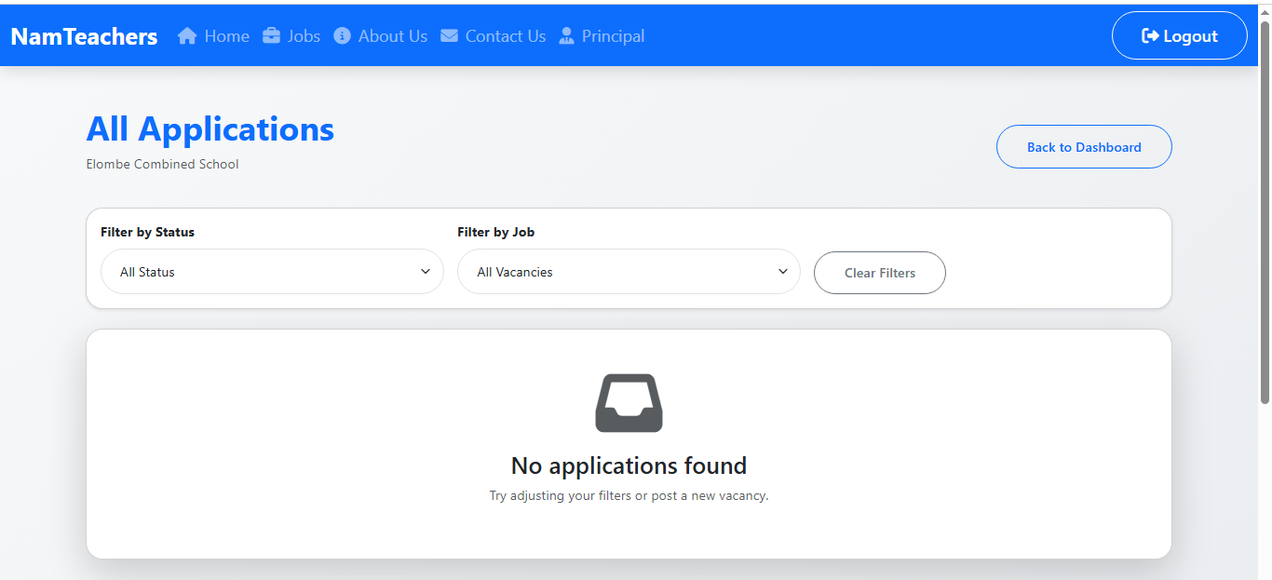
Principal view all applications

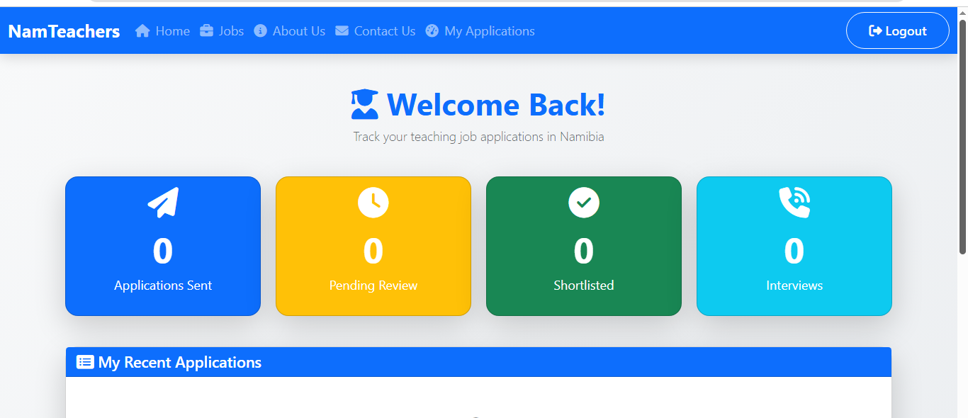
Job seeker dashboard
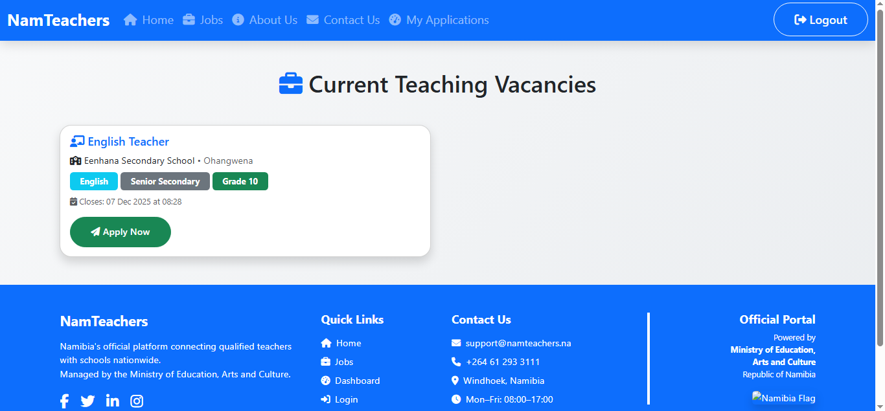
Available teaching vacancies
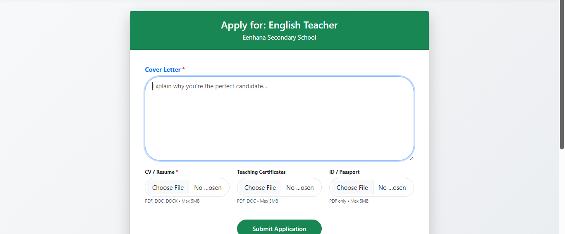
Vacancy application form

3.7 Database Design
The system uses a relational database (MySQL) to ensure data integrity.
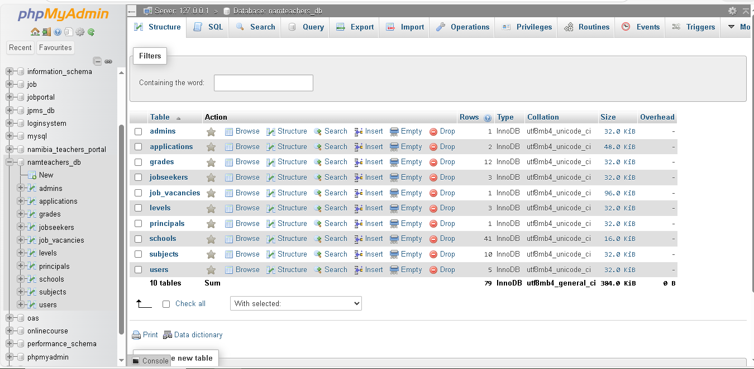

Fig. 3.7 :Database Design

Table 3.7.1: schools table
Field | Data Type | Null | Default | Key | Description
id | int(11) | No | None | PRI | AUTO_INCREMENT
name | varchar(255) | No | None
region | varchar(100) | Yes | NULL
town | varchar(100) | Yes | NULL
address | text | Yes | NULL
phone | varchar(20) | Yes | NULL
status | enum('active', 'inactive') | Yes | active

Table 3.7.2: applications table
Field | Data Type (Inferred) | Null | Default | Key | Description
id | int(11) | No | None | PRI | AUTO_INCREMENT
vacancy_id | int(11) | No | None | MUL | Foreign Key
jobseeker_id | int(11) | No | None | MUL | Foreign Key
cover_letter | text | Yes | NULL
applied_at | datetime | Yes | current_timestamp()
status | varchar(50) | Yes | submitted
cv_path | varchar(255) | Yes | NULL
cert_path | varchar(255) | Yes | NULL
id_path | varchar(255) | Yes | NULL

Table 3.7.3: job vacancies table
Field | Data Type | Null | Default | Key | Description
id | int(11) | No | None | PRI | AUTO_INCREMENT
school_id | int(11) | Yes | NULL | MUL
subject_id | int(11) | Yes | NULL | MUL
level_id | int(11) | Yes | NULL | MUL
grade_id | int(11) | Yes | NULL | MUL
title | varchar(255) | Yes | NULL
description | longtext | Yes | NULL
posting_date | datetime | Yes | current_timestamp()
closing_datetime | datetime | No | None
status | enum('open', 'closed', 'filled') | Yes | open
created_by | int(11) | Yes | NULL | MUL

Table 3.7.4: principals table
Field | Data Type | Null | Default | Key | Description
id | int(11) | No | None | PRI | AUTO_INCREMENT
user_id | int(11) | Yes | NULL | MUL
school_id | int(11) | Yes | NULL
first_name | varchar(100) | Yes | NULL
last_name | varchar(100) | Yes | NULL
phone | varchar(20) | Yes | NULL

Table 3.7.5: jobseekers table
Field | Data Type | Null | Default | Key | Description
id | int(11) | No | None | PRI | AUTO_INCREMENT
user_id | int(11) | Yes | NULL | MUL
first_name | varchar(100) | No | None
last_name | varchar(100) | No | None
phone | varchar(20) | Yes | NULL

Table 3.7.6: users table

Field | Data Type | Null | Default | Key | Description
id | int(11) | No | None | PRI | AUTO_INCREMENT
email | varchar(255) | No | None | UNI
password | varchar(255) | No | None
role | enum('admin', 'principal', 'jobseeker') | No | None
status | enum('active', 'inactive') | Yes | active
created_at | datetime | Yes | current_timestamp()

Table 3.7.7: grades table

Field | Data Type | Null | Default | Key | Description
id | int(11) | No | None | PRI | AUTO_INCREMENT
name | varchar(20) | No | None

Table 3.7.8: subjects table
Field | Data Type | Null | Default | Key | Description
id | int(11) | No | None | PRI | AUTO_INCREMENT
name | varchar(100) | No | None

Table 3.7.9: admins table
Field | Data Type | Null | Default | Key | Description
id | int(11) | No | None | PRI | AUTO_INCREMENT
user_id | int(11) | Yes | NULL | MUL
first_name | varchar(100) | Yes | NULL
last_name | varchar(100) | Yes | NULL

Table 3.7.10: levels table
Field | Data Type | Null | Default | Key | Description
id | int(11) | No | None | PRI | AUTO_INCREMENT
name | varchar(50) | No | None

3.8 Hardware and Software System Requirements

Table 3.8.1. Minimum Hardware requirement
Hardware | Minimum Requirement
Hard drive | 500GB
Random Access Memory (RAM) | 4GB
Machine/computer/device | Any device

Table 3.8.2. Minimum Software requirement
Software | Minimum requirement
Text editor: Visual Studio Code | 1.43 KB (1,467 bytes)
Database: Xampp Control Panel (version 3.3.0) | 671bytes
Operating system | Windows 8

Backend (Server-Side & Database)
These tools handle the "behind the scenes" work: storing data, processing logic, and managing the server.
Server Environment: XAMPP (or WAMP/MAMP) -This is the software bundle likely installed on your computer to run the local server. It includes Apache, MySQL, and PHP in one package.
Database Management: phpMyAdmin - It provides a visual interface to manage the MySQL database without writing raw SQL commands for everything.
Database Engine: MySQL (or MariaDB) - The actual system storing tables (users, schools, etc.). It processes the SQL queries.
Web Server: Apache HTTP Server -Part of XAMPP; this software listens for requests from the browser and serves the web pages.
Scripting Language: PHP - The programming language that connects your database to the webpage. It handles logic like "User Login," "Save Application," or "Check Password."

Frontend (User Interface / Client-Side)
These are the tools used to create what the user actually sees and interacts with on the screen.
Structure: HTML (HyperText Markup Language) - Used to build the skeleton of pages (forms, tables, headings).
Styling: CSS (Cascading Style Sheets) - Used to make the pages look good (colors, layout, fonts).
Interactivity: JavaScript - Used for dynamic features, like pop-up alerts or validating a form before it is submitted.
Testing/Viewing Tool: Web Browser (Chrome, Edge, Firefox) - The software used to render the code and display the interface to the user.

3.9 Summary
This chapter provided a detailed exposition of the analysis and design phase of the Namibia Teachers Recruitment Portal. It began by outlining the data gathering techniques, which confirmed the urgent need for a digital solution to transport costs. The Agile methodology was justified as the most appropriate approach for this iterative project. The system design section detailed the MVC architecture and provided a comprehensive database schema. Finally, the hardware and software tools used for construction were listed. The specifications detailed in this chapter form the basis for the Implementation phase, which is discussed in the following chapter.

CHAPTER 4: `IMPLEMENTATION

4.1 Introduction
The implementation phase marks the transition from the system design specifications to the construction of the actual software product. This chapter details the technical realization of the NamTeachers recruitment system. It focuses on the backend logic, database connectivity, and the algorithms used to process data securely and efficiently.

4.1.1 Database Connection Configuration
The foundation of the system relies on a secure connection between the PHP frontend and the MySQL database. The following code (db_connect.php) is included in every file that requires data access.
Source code for Login
On the address bar of any browser type localhost/NamTeachers-Portal/auth/login.php

<?php require '../includes/auth.php';
if(is_logged_in()) header("Location: ../public/index.php");
require '../includes/header.php';
?>

<div class="container py-5 d-flex align-items-center justify-content-center min-vh-100">
<div class="col-md-5 col-lg-4">
<div class="card shadow-lg border-0">
<div class="card-body p-5 text-center">
<i class="fas fa-chalkboard-teacher fa-5x text-primary mb-4"></i>
<h2 class="fw-bold mb-4">Welcome Back</h2>
<p class="text-muted mb-4">Login as Admin, Principal or Job Seeker</p>

<form id="loginForm">
<div class="input-group mb-4">
<span class="input-group-text"><i class="fas fa-envelope"></i></span>
<input type="email" name="email" class="form-control form-control-lg" placeholder="Email Address" required>
</div>

<div class="input-group mb-4">
<span class="input-group-text"><i class="fas fa-lock"></i></span>
<input type="password" name="password" id="password" class="form-control form-control-lg" placeholder="Password" required>
<button class="btn btn-outline-secondary" type="button" onclick="togglePass()">
<i class="fas fa-eye" id="eye"></i>
</button>
</div>

<button type="submit" class="btn btn-primary btn-lg w-100">
<i class="fas fa-sign-in-alt"></i> Login Now
</button>
</form>

<p class="mt-4 text-muted">
Don't have an account?
<a href="register_jobseeker.php" class="fw-bold text-primary">Register as Job Seeker</a>
</p>
</div>
</div>
</div>
</div>

<!-- SweetAlert2 -->
<script src="https://cdn.jsdelivr.net/npm/sweetalert2@11"></script>
<script>
function togglePass() {
const pass = document.getElementById('password');
const eye = document.getElementById('eye');
if (pass.type === 'password') {
pass.type = 'text';
eye.classList.replace('fa-eye', 'fa-eye-slash');
} else {
pass.type = 'password';
eye.classList.replace('fa-eye-slash', 'fa-eye');
}
}

// AJAX Login
document.getElementById('loginForm').addEventListener('submit', function(e) {
e.preventDefault();
const formData = new FormData(this);

fetch('../ajax/login.php', {
method: 'POST',
body: formData
})
.then(response => response.json())
.then(data => {
if (data.success) {
Swal.fire({
icon: 'success',
title: 'Login Successful!',
text: 'Welcome back to NamTeachers',
timer: 1500,
showConfirmButton: false
}).then(() => {
window.location.href = '../public/index.php';
});
} else {
Swal.fire({
icon: 'error',
title: 'Login Failed',
text: data.message || 'Invalid email or password'
});
}
})
.catch(() => {
Swal.fire('Error', 'Connection failed. Please try again.', 'error');
});
});
</script>

<?php require '../includes/footer.php'; ?>
The source code show the function that allows users to enter correct credentials, so that they can proceed to their dashboard.

Source code for Admin Dashboard
<?php require '../includes/auth.php'; require_role('admin'); require '../includes/header.php';
global $mysqli;

$total_jobs = $mysqli->query("SELECT COUNT(*) FROM job_vacancies WHERE status='open'")->fetch_row()[0];
$applications = $mysqli->query("SELECT COUNT(*) FROM applications")->fetch_row()[0];
$schools = $mysqli->query("SELECT COUNT(*) FROM schools")->fetch_row()[0];
?>

<div class="container py-5">
<h1 class="text-center mb-5"><i class="fas fa-cogs text-purple fa-3x"></i> Admin Panel</h1>

<div class="row g-4 text-white">
<div class="col-md-4">
<div class="card bg-primary shadow">
<div class="card-body text-center">
<i class="fas fa-briefcase fa-4x mb-3"></i>
<h2><?php echo $total_jobs; ?></h2>
<p>Open Vacancies</p>
</div>
</div>
</div>
<div class="col-md-4">
<div class="card bg-success shadow">
<div class="card-body text-center">
<i class="fas fa-users fa-4x mb-3"></i>
<h2><?php echo $applications; ?></h2>
<p>Applications</p>
</div>
</div>
</div>
<div class="col-md-4">
<div class="card bg-teal shadow">
<div class="card-body text-center">
<i class="fas fa-school fa-4x mb-3"></i>
<h2><?php echo $schools; ?></h2>
<p>Registered Schools</p>
</div>
</div>
</div>

<div class="row mt-5">
<div class="col-md-6">
<a href="create_job.php" class="btn btn-lg btn-primary w-100 py-4">
<i class="fas fa-plus-circle"></i> Post New Job
</a>
</div>
<div class="col-md-6">
<a href="register_principal.php" class="btn btn-outline-primary btn-lg w-100 py-4">
<i class="fas fa-user-tie"></i> Register Principal
</a>
</div>
</div>
</div>

<?php require '../includes/footer.php'; ?>
The source code show the function that allows admin to change all the user’s status (edit, add, delete).

Source code for Job Seeker Dashboard
<?php
require '../includes/auth.php';
require_role('jobseeker');
require '../includes/header.php';
global $mysqli;

$seeker = $mysqli->query("SELECT id FROM jobseekers WHERE user_id = {$_SESSION['user_id']}")->fetch_row()[0];

// Stats
$total_applied = $mysqli->query("SELECT COUNT(*) FROM applications WHERE jobseeker_id = $seeker")->fetch_row()[0];
$pending = $mysqli->query("SELECT COUNT(*) FROM applications WHERE jobseeker_id = $seeker AND status = 'submitted'")->fetch_row()[0];
$shortlisted = $mysqli->query("SELECT COUNT(*) FROM applications WHERE jobseeker_id = $seeker AND status = 'shortlisted'")->fetch_row()[0];
$interviews = $mysqli->query("SELECT COUNT(*) FROM applications WHERE jobseeker_id = $seeker AND status = 'interview'")->fetch_row()[0];
?>

<div class="container py-5">
<div class="text-center mb-5">
<h1 class="display-5 fw-bold text-primary">
<i class="fas fa-user-graduate"></i> Welcome Back!
</h1>
<p class="lead text-muted">Track your teaching job applications in Namibia</p>
</div>

<!-- Stats Cards -->
<div class="row g-4 mb-5">
<div class="col-md-3">
<div class="card text-white bg-primary shadow-lg h-100">
<div class="card-body text-center">
<i class="fas fa-paper-plane fa-3x mb-3"></i>
<h2 class="display-4 fw-bold"><?= $total_applied ?></h2>
<p class="fs-5">Applications Sent</p>
</div>
</div>
</div>
<div class="col-md-3">
<div class="card text-white bg-warning shadow-lg h-100">
<div class="card-body text-center">
<i class="fas fa-clock fa-3x mb-3"></i>
<h2 class="display-4 fw-bold"><?= $pending ?></h2>
<p class="fs-5">Pending Review</p>
</div>
</div>
</div>
<div class="col-md-3">
<div class="card text-white bg-success shadow-lg h-100">
<div class="card-body text-center">
<i class="fas fa-check-circle fa-3x mb-3"></i>
<h2 class="display-4 fw-bold"><?= $shortlisted ?></h2>
<p class="fs-5">Shortlisted</p>
</div>
</div>
</div>
<div class="col-md-3">
<div class="card text-white bg-info shadow-lg h-100">
<div class="card-body text-center">
<i class="fas fa-phone-volume fa-3x mb-3"></i>
<h2 class="display-4 fw-bold"><?= $interviews ?></h2>
<p class="fs-5">Interviews</p>
</div>
</div>
</div>
</div>

<!-- Recent Applications -->
<div class="card shadow-lg">
<div class="card-header bg-primary text-white">
<h4 class="mb-0"><i class="fas fa-list-alt"></i> My Recent Applications</h4>
</div>
<div class="card-body">
<?php
$apps = $mysqli->query("SELECT a.*, j.title, s.name as school, j.closing_datetime
FROM applications a
JOIN job_vacancies j ON a.vacancy_id = j.id
JOIN schools s ON j.school_id = s.id
WHERE a.jobseeker_id = $seeker
ORDER BY a.applied_at DESC LIMIT 10");

if($apps->num_rows == 0): ?>
<p class="text-center text-muted py-5">
<i class="fas fa-search fa-3x mb-3"></i><br>
No applications yet. <a href="../public/jobs.php" class="text-primary fw-bold">Browse Jobs →</a>
</p>
<?php else: ?>
<div class="table-responsive">
<table class="table table-hover align-middle">
<thead class="table-primary">
<tr>
<th>Job Title</th>
<th>School</th>
<th>Applied On</th>
<th>Status</th>
<th>Closes</th>
</tr>
</thead>
<tbody>
<?php while($app = $apps->fetch_assoc()): ?>
<tr>
<td><strong><?= htmlspecialchars($app['title']) ?></strong></td>
<td><?= htmlspecialchars($app['school']) ?></td>
<td><?= date('d M Y', strtotime($app['applied_at'])) ?></td>
<td>
<span class="badge bg-<?=
$app['status']=='shortlisted' ? 'success' :
($app['status']=='interview' ? 'info' :
($app['status']=='rejected' ? 'danger' : 'secondary'))
?>">
<?= ucfirst($app['status']) ?>
</span>
</td>
<td><?= date('d M Y', strtotime($app['closing_datetime'])) ?></td>
</tr>
<?php endwhile; ?>
</tbody>
</table>
</div>
<?php endif; ?>
</div>
</div>

<div class="text-center mt-5">
<a href="../public/jobs.php" class="btn btn-success btn-lg px-5">
<i class="fas fa-search"></i> Find More Jobs
</a>
</div>
</div>

<?php require '../includes/footer.php'; ?>
The source code show the function that allows job seekers to apply, edit and track their application status .
4.2 Conclusion
The system was developed using PHP for server-side processing and MySQL for data management. While the complete source code, including the HTML/CSS user interfaces and client-side scripts, is attached in the accompanying compact disk (CD), this chapter presents specific code snippets that power the core functionalities of the system, such as authentication, data storage, and application processing.

CHAPTER 5: TESTING

5.1 Introduction
This chapter documents the systematic verification and validation processes undertaken to ensure the Namibia Teachers Recruitment Portal meets the functional and non-functional requirements defined in Chapter 3. The primary objective of the testing phase was to detect and rectify errors within the system’s logic, ensuring that the "wage less" features such as remote interviewing and low-bandwidth file uploads function correctly under realistic conditions. This chapter outlines the testing strategies employed, including Unit Testing, Integration Testing, System Testing, and User Acceptance Testing (UAT). It concludes with a summary of the test results, demonstrating the system's readiness for deployment by the Ministry of Education, Arts and Culture (MoEAC).

Testing Strategy
The study adopted a hybrid testing strategy combining White Box Testing (analyzing internal code structures) and Black Box Testing (evaluating external functionality). This approach was necessary to ensure that both the technical backend (Laravel PHP logic) and the user experience (Bootstrap UI) were robust.
Test Environment
To simulate the real-world conditions of the target user base (rural unemployed teachers), testing was conducted in two distinct environments:
- Development Environment (Localhost):
  - Server: XAMPP (Apache/MySQL) on Windows 10.
  - Network: High-speed Wi-Fi (Fiber).
  - Purpose: To verify code logic and database integrity.
- Staging Environment (Simulated Rural Context):
  - Device: Mid-range Smartphone (Samsung Galaxy A-series) and a 5-year-old Laptop.
  - Network: 3G Mobile Hotspot with throttled bandwidth (512 kbps).
  - Purpose: To validate the "low-bandwidth" requirements and mobile responsiveness.

Unit Testing
Unit testing involved verifying the smallest testable parts of the application, such as individual functions and classes within the Laravel framework. These tests were automated using PHPUnit, the standard testing framework for PHP.
Key Unit Tests
The following table summarizes the critical unit tests performed on the backend logic.
Test ID | Unit Name | Test Description | Input Data | Expected Output | Status
UT-01 | calculateMatchScore() | Validates the algorithm that compares applicant qualifications with job requirements. | Qual: "B.Ed Honours", Req: "B.Ed Honours" | Return Score: 100 | PASS
UT-02 | fileCompression() | Tests if the PDF upload function correctly compresses files larger than 2MB. | File: CV_Large.pdf (5MB) | File Saved < 2MB | PASS
UT-03 | sendSMSNotification() | Verifies that the SMS gateway API is triggered when an interview is scheduled. | Phone: +264811234567 | API Response: 200 OK | PASS
UT-04 | validateNamibianID() | Checks if the User Registration form correctly validates a 11-digit ID number. | ID: 95010100123 | Return: True | PASS

Table 5.1.1. Unit Testing

User Acceptance Testing (UAT)
UAT is the final phase of testing, performed by the intended users to verify that the solution solves the real-world problem.
UAT Participants
- Group A: 5 Unemployed Teachers (varying digital literacy).
- Group B: 2 Ministry HR Administrators.
A post-test questionnaire was administered.
Question | Average Score (out of 5) | Interpretation
Is the system easy to use? | 4.2 | Users found the interface intuitive.
Does the system save you money? | 4.8 | High agreement on the financial benefit.
Would you trust this over the manual system? | 4.5 | High trust in the digital process.

Table 5.1.2. post-test questionnaire

5.2 Chapter Summary
The testing phase confirmed that the Namibia Teachers Recruitment Portal functions correctly and effectively addresses the identified problems. Unit testing verified the logic of the matching algorithms, while Integration testing ensured seamless data flow. Most importantly, System and User Acceptance Testing demonstrated that the portal is viable for use in rural, low-bandwidth environments, directly solving the "wageless" cost of compliance for unemployed teachers. The successful completion of these tests validates the system for deployment. The final chapter will present the conclusions and recommendations for future work.

CHAPTER 6: CONCLUSION AND FUTURE WORK

6.1 Introduction
This study set out to address the critical "wageless" crisis facing unemployed teachers in Namibia, characterized by prohibitive transport costs, geographic exclusion, and administrative inefficiencies within the manual recruitment system. Through a mixed-method approach, the researcher analyzed the financial burden placed on rural graduates who must currently travel long distances to regional directorates to submit applications. The study successfully designed, developed, and tested the Namibia Teachers Recruitment Portal, a web-based solution that digitizes the entire recruitment value chain. By integrating a low-bandwidth application interface and a remote VoIP interview module, the system directly eliminates the need for physical travel, thereby democratizing access to employment opportunities for candidates from low socio-economic backgrounds.

6.2 Conclusion
The findings of this project confirm that digital intervention is not only viable but essential for the modernization of the Ministry of Education, Arts and Culture’s (MoEAC) recruitment processes.
- Financial Equity: The User Acceptance Testing (UAT) demonstrated that the portal significantly reduces the "cost of compliance" for job seekers. Participants confirmed that attending interviews via the portal saved them an average of N$300–N$800 per application cycle in transport and accommodation fees.
- Administrative Efficiency: The system addressed the issue of lost documentation and nepotism by creating a centralized, auditable digital trail for every application. The automated shortlisting algorithm reduced the time required to filter candidates from weeks to minutes, allowing HR officials to focus on qualitative assessment rather than manual sorting.
- Strategic Alignment: The developed system aligns with the national goals of the Harambee Prosperity Plan II, which emphasizes the digitization of public services to improve governance and service delivery.

6.3 Future Work
Future iterations of this project could expand on the foundational features developed here:
- Block chain Verification: Implementing a block chain-based ledger for academic transcripts would allow for instant, tamper-proof verification of qualifications, eliminating the need for certified paper copies entirely.
- Offline-First Mobile App: Developing a native Android application that allows users to fill out forms offline and sync data automatically when a connection becomes available would further support users in unstable network zones.
- Integration with Home Affairs: Linking the portal directly with the Ministry of Home Affairs API would automate identity verification, reducing the incidence of fraudulent applications.
6.4 Chapter Summary
This study set out to address the critical "wageless" crisis facing unemployed teachers in Namibia, characterized by prohibitive transport costs, geographic exclusion, and administrative inefficiencies within the manual recruitment system. Through a mixed-method approach, the researcher analyzed the financial burden placed on rural graduates who must currently travel long distances to regional directorates to submit applications. The study successfully designed, developed, and tested the Namibia Teachers Recruitment Portal, a web-based solution that digitizes the entire recruitment value chain. By integrating a low-bandwidth application interface and a remote VoIP interview module, the system directly eliminates the need for physical travel, thereby democratizing access to employment opportunities for candidates from low socio-economic backgrounds.
In conclusion, the Namibia Teachers Recruitment Portal represents a scalable solution to a systemic problem. It transforms the recruitment process from a barrier to entry into a gateway of opportunity, ensuring that the most qualified teachers regardless of their location or financial status can contribute to the education of the Namibian child.

REFERENCES
Davis, F. D. (1989). Perceived usefulness, perceived ease of use, and user acceptance of information technology. MIS Quarterly, 13(3), 319–340. https://doi.org/10.2307/249008
Government Gazette. (2023). General notice: Domestic postal tariffs 2023/2024. Republic of Namibia. https://www.lac.org.na/laws/2023/8184.pdf
Henry, J. (2020). Rethinking schooling for development in wageless times. African Geographical Review, 39(1), 1-15. https://doi.org/10.1080/19376812.2020.1738367
Informanté. (2025, June 3). Unemployed Oshana teachers threaten to camp for job. https://informante.web.na/?p=376173
Mergel, I., Ganapati, S., & Whitford, A. B. (2021). Agile: A new way of governing. Public Administration Review, 81(1), 161–165. https://doi.org/10.1111/puar.13202
Namibian Sun. (2025, July 8). Unemployed teachers demand overhaul of interview processes. https://www.namibiansun.com/education/unemployed-teachers-demand-overhaul-of-interview-processes2025-07-08
Namupala, N. (2016). “One that has given you little has your soul consoled”–unemployed youth on surviving without unemployment benefits in Namibia [Master’s thesis, University of Namibia]. UNAM Repository. http://repository.unam.edu.na/handle/11070/1749
NBC News. (2025, July 10). PSC calls for urgent reforms in recruitment, Digitisation. https://nbcnews.na/node/110976
NBC News. (2025, July 10). Unemployed qualified teachers bemoan costly interviews. https://www.nbcnews.na/node/111223
Ndiwakalunga, I. O. (2015). Access coverage for remote connectivity framework (ACRCF): Facilitating scholarship awarding in Namibia [Master’s thesis, University of Namibia]. UNAM Repository. http://repository.unam.edu.na/handle/11070/1446
New Era. (2023, January 9). Opinion – Abolish job interviews for teachers. https://neweralive.na/opinion-abolish-job-interviews-for-teachers/
Shikalepo, E. E. (2019). Teacher Recruitment, Motivation and Retention at Rural Schools in Namibia. European Educational Researcher, 2(1), 1-18. https://files.eric.ed.gov/fulltext/ED595436.pdf
Somaeb, R. M. (2017). An investigation of the effectiveness of employee recruitment procedures in the headquarters of the Ministry of Education, Arts and Culture in Namibia [Master’s thesis, University of Namibia]. UNAM Repository. http://repository.unam.na/handle/11070/2034
The Brief. (2025, April 25). Govt plans to automate recruitment process for civil service. The Brief Namibia. https://epaper.thebrief24.com/2025/April+2025/The+Brief_25+April+2025.pdf

E. Research Project Appendices
Appendix A – User Manual

1. Introduction
NamTeachers is the official government-backed web portal for teacher recruitment in Namibia, managed by the Ministry of Education, Arts and Culture. The platform connects qualified educators with schools across all 14 regions, streamlining the recruitment process.
Who is this manual for?
- Job Seekers: Qualified teachers looking for employment.
- Principals: School leaders reviewing applications.
- Administrators: Regional/National officials managing vacancies and users.

2. General Access & Login
All users access the platform through the main homepage.
- Homepage: Navigate to the NamTeachers website to view the main menu (Home, Jobs, About Us, Contact Us).
- Login: Click the Login button at the top right corner. This directs to a unified login page for Admins, Principals, and Job Seekers.
  - Enter your Email Address and Password.
  - Click Login Now to access your specific dashboard.

3. For Job Seekers (Teachers)

3.1 Creating an Account
If you do not have an account, you must register before applying.
- On the Login page, click Register as Job Seeker.
- Fill in the registration form with:
  - First Name and Last Name.
  - Email Address.
  - Password (and confirm it).
  - Phone Number (Optional).
- Click Create Account to proceed.

3.2 Your Dashboard
Once logged in, you will see the Job Seeker Dashboard, which tracks your activity.
- Applications Sent: Total jobs applied for.
- Pending Review: Applications waiting to be seen.
- Shortlisted: Applications selected for the next stage.
- Interviews: Scheduled interviews.

3.3 Finding and Applying for Jobs
- Browse Vacancies: Navigate to the Jobs section or scroll to "Current Teaching Vacancies" on your dashboard. You can see the Job Title, School, Region, Subjects, and Grade level (e.g., Grade 10).
- View Details: Review the closing date and specific requirements.
- Apply: Click the Apply Now or Login to Apply button.

3.4 Submitting an Application
When applying for a specific role (e.g., English Teacher), you must complete the application form:
- Cover Letter: Type your motivation in the text box explaining why you are the perfect candidate.
- Upload Documents:
  - CV / Resume: Required (PDF, DOC, DOCX, Max 5MB).
  - Teaching Certificates: Optional but recommended (PDF, DOC, Max 5MB).
  - ID / Passport: Optional (PDF only, Max 5MB).
- Click Submit Application.

4. For Principals

4.1 Principal Dashboard
Upon logging in, you will see the Principal Dashboard, which displays your school name and region (e.g., Elombe Combined School, Oshikoto Region). Key Metrics:
- Active Vacancies: Jobs currently posted for your school.
- Total Applications: Total candidates who have applied.
- Pending Review: Applications you haven't processed yet.
- School Managed: The number of schools under your profile.

4.2 Managing Applications
- To view candidates, click on Recent Applications or navigate to the applications section.
- Filter: You can filter the list by Status (e.g., Shortlisted, Rejected) or by Job (Vacancies).
- Review & Action:
  - You can view applicant details.
  - You have the ability to change the status of an application (e.g., mark as Shortlisted, Interview, etc.).

5. For Administrators

5.1 Admin Dashboard
The Admin Panel provides a high-level overview of the system. Overview Stats:
- Open Vacancies: Currently active job posts.
- Applications: Total applications received across the system.
- Registered Schools: Total number of schools in the database.

5.2 Posting a New Vacancy
To recruit for a school, click Post New Job on the dashboard.
- Select School: Choose the school from the dropdown menu.
- Job Details: Enter the Job Title (e.g., Mathematics Teacher).
- Classifications: Select the Subject, Level, and Grade.
- Description: Enter the full job description and requirements.
- Closing Date: Use the calendar picker to set the deadline (dd/mm/yyyy --:--).
- Click Post Job to publish it live.

5.3 Registering a Principal
Admins are responsible for onboarding Principals. Click Register Principal on the dashboard.
- Enter the Principal's First Name and Last Name.
- Enter the Email (this will be their login username).
- Create a temporary Password.
- Enter their Phone Number.
- Select School: Assign them to the correct school from the dropdown.
- Click Register Principal.

6. Support & Contact
If you encounter technical issues or need assistance:
- Email: support@namteachers.na
- Phone: +264 61 293 3111
- Hours: Mon–Fri: 08:00–17:00
- Address: Windhoek, Namibia

Appendix B – Screen Shots

Home page
All user login page

Job seeker/teacher registration page
Available teaching vacancies dashboard
Admin Dashboard
Posting of New Teaching Vacancy form
Principal registration form
Principal Dashboard
Principal view all applications
Job seeker dashboard
Available teaching vacancies
Vacancy application form

Appendix C – Project Proposal

